m

Alfreton Town Council

Planning Committee

Agenda 19th June 2024

AGENDA

PLANNING COMMITTEE
13/06/24
Chairman: Councillor Keith Wood
Councillors: D Taylor, J Gdula, J Whetton & J Bate

On Wednesday 19th June 2024 at 7:00pm

ROOM 1, Alfreton House

All Members of the Committee are summoned to attend for the purpose of considering and resolving the business to be transacted as set out in the following agenda.

Please note that all members are invited to attend and participate at the meeting but any decision on any representation may only be made by members of the Planning Committee.

Yours sincerely,
Tina Crookes
Tina Crookes
Town Clerk and Proper Officer

MEETING OF ALFRETON TOWN COUNCIL

ORDER OF BUSINESS

01/24p To receive apologies for absence

02/24p To receive any declarations of interest from Members
Members are requested to declare the existence and nature of any disclosable pecuniary interest and/or other interest, not already on their register of interests, in any item on the agenda and withdraw from the meeting at the appropriate time, or to request a dispensation. Please note that appropriate forms should be completed prior to commencement of the meeting.

03/24p Recording and Filming of Council and Committee Meetings
The right to record, film and to broadcast meetings of the council and committees is established following the Local Government Audit and Accountability Act 2014. This is in addition to the rights of the press and public to attend such meetings. Meetings or parts of the meetings from which the press and public are excluded may not be filmed or recorded. Members of the public are permitted to film or record meetings to which they are permitted access, in a non-disruptive manner.

a. For the purposes of minute taking an Officer will record the meeting audially and delete the files once the draft minutes have been produced.

04/24p Public Participation
The period of time designated for public participation at a meeting shall not exceed 20 minutes, a member of the public shall not speak for more than 3 minutes, unless directed by the Town Mayor of the meeting.
A question may only be asked if notice has been given by delivering it in writing or e-mail to the Town Clerk 7 clear days before the meeting, unless the Town Mayor regards it as urgent in his opinion.
A separate public participation procedure exists.
Link to Alfreton Town Council policies and procedures

05/24p To consider any items which should be taken in exclusion of the press and public
If the Council decides to exclude the press and public it will be necessary to pass a resolution in the following terms:- “That in view of the confidential nature of the business about to be transacted, to consider a resolution to exclude the Press and Public from the meeting in accordance with the Public Bodies (Admission to Meetings) Act 1960, s1, in order to discuss the item. A reason must be stated

06/24p To hear from a representative of Save Our Countryside Action Group

07/24p To consider what representations, if any, the Town Council wishes to make on:

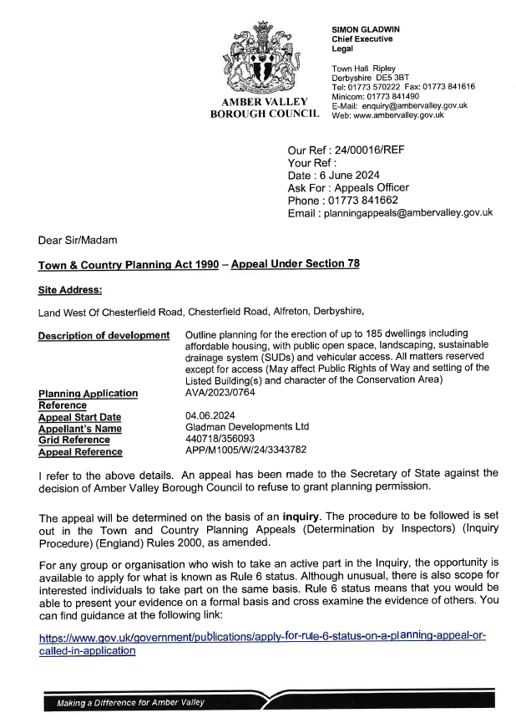
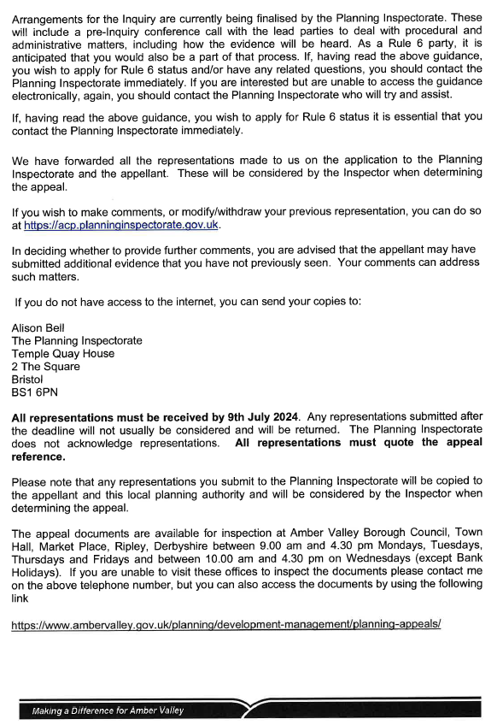

Consultation Date - 15/May/2024
Ref: AVA/2024/0329
Address: Rayville , Grange Street, Alfreton, Derbyshire, DE55 7HZ
Proposal: Creation of vehicle access
Date Valid:9/May/2024
Decision Expected:27/Jun/2024
Decision Issued:
Applicant: Mr Simon Houlton New Tor, Grange Street, Alfreton, DE55 7HZ, United Kingdom
Officer: Rebecca Smith (rebecca.smith@ambervalley.gov.uk)
Consultees: APAR, DCCHB

Consultation Date - 15/May/2024
Ref: AVA/2024/0330
Address: Arkholme , Grange Street, Alfreton, Derbyshire, DE55 7HZ
Proposal: Creation of vehicle access
Date Valid:9/May/2024
Decision Expected:27/Jun/2024
Applicant: Mr Simon Houlton New Tor, Grange Street, Alfreton, DE55 7HZ, United Kingdom
Officer: Rebecca Smith (rebecca.smith@ambervalley.gov.uk)
Consultees: APAR, DCCHB,

Consultation Date - 21/May/2024
Ref: AVA/2024/0352
Address: Land North Of Alfreton (South Of B6025), Meadow Lane, Alfreton, Derbyshire, ,Proposal: Variation of condition 3 (approved drawings) of AVA/2021/0313 for an update to equipment details on site, slight relocation over modules, extension to main access track and very minor amendment to the RLB crossing the brook (This may affect the setting of a listed building)
Date Valid:17/May/2024
Decision Expected:2/Aug/2024
Applicant: Mrs Jez McHale Anesco Ltd, The Green, Easter Park, Benyon Road, Reading, Berkshire, RG7 2PQ, United Kingdom
Officer: Alan Redmond (alan.redmond@ambervalley.gov.uk)
Consultees: APAR, DCCHB, FLOOD, EA, DWT, MMORIS,

Consultation Date - 24/May/2024
Ref: AVA/2024/0320
Address: New Bengal Balti &Tandoori Restaurant, 3 King Street, Alfreton, Derbyshire, DE55 7AF
Proposal: Change of use from existing use class E to Sui Generis, 8 bedroom, 8 person HMO with associated external alterations including a single storey rear extension. (may affect the setting of a Listed building)
Date Valid:24/May/2024
Decision Expected:12/Jul/2024
Applicant: Mr Jay Sandhu 3 King's Street, Alfreton, DE55 7AE,
Officer: Laura Anthony (laura.anthony@ambervalley.gov.uk)
Consultees: APAR, DCCHB, HOUSE, AVWAST, POL, HERCON,

Consultation Date - 28/May/2024
Ref: AVA/2024/0344
Address: Cocoa Mint, 19 - 19A Church Street, Alfreton, Derbyshire, DE55 7AN
Proposal: Change of use from class E retail on ground floor to Sui Generis (Bar and Cocktail lounge) to include new external signage and illuminated external down lighting (may affect the setting of a listed building)
Date Valid:24/May/2024
Decision Expected:12/Jul/2024
Applicant: Mr Thomas Luckwell 19 - 19A Church Street, Alfreton, Derbyshire, DE55 7AN,
Officer: Laura Anthony (laura.anthony@ambervalley.gov.uk)
Consultees:APAR, DCCHB, POL, HERCON,

Consultation Date - 4/Jun/2024
Ref: AVA/2024/0382
Address: ATLAS BUILDING CIVIL & ENG LTD, 55A Mansfield Road, Alfreton, Derbyshire, DE55 7JJ
Proposal: Conversion of Class E (office) and extension to first floor to provide two, one bedroom apartments
Date Valid:29/May/2024
Decision Expected:17/Jul/2024
Applicant: Mr / Mrs P / D Richardson, Harker DPPH Ltd, CO JF Planning , 45 Bakehouse Lane , Ockbrook, Derby, DE723RH
Officer: Laura Anthony (laura.anthony@ambervalley.gov.uk)
Consultees: APAR, DCCHB, DWT, POL, CON, COAL,

Consultation Date - 5/Jun/2024
Ref: AVA/2024/0397
Address:11 Copthorne Drive, Alfreton, Derbyshire, DE55 7SR,
Proposal: Construction of an outbuilding in the rear garden
Date Valid:5/Jun/2024
Decision Expected:24/Jul/2024
Applicant: Mr Kieran Marriott 11 Copthorne Drive, Alfreton, Derbyshire, DE55 7SR,
Officer: Rebecca Smith (rebecca.smith@ambervalley.gov.uk)
Consultees:APAR,

Ref: AVA/2024/0397
Address: 59, 61 And 63 High Street Alfreton Derbyshire
Proposal: Conversion of existing first & second floor to form 8 residential flats.
Applicant name: Mr S Ghai
Applicant address: Homelet, The Bank 1 King Street Alfreton Derbyshire DE55 7DB
Officer name:Laura Anthony
Status: Pending Consideration
Decision type: Delegated
Anticipated decision date: 29-July-2024

