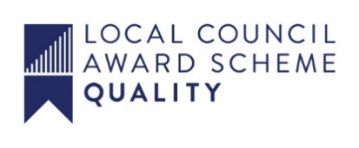

ALFRETON TOWN COUNCIL
Application for the Role of Councillor, Alfreton Town Council
Full name
Home address
Inc. Postcode
Telephone number
Mobile number
Email

Legal qualifications for being a town councillor.
(To qualify you must be able to answer ‘Yes’ to both of the questions below)
Are you a British citizen, a Commonwealth citizen or a citizen of a European Union country? | Yes/No.
Are you 18 or over? | Yes/No.

(To qualify you must be able to answer ‘Yes’ to at least one of the questions below)
Are you on the electoral register for the parish of Alfreton? | Yes/No.
Have you lived either in the ward of Alfreton, or within three miles of its boundary, for at least a year? | Yes/No.
Have you been the owner or tenant of land in the ward of Alfreton for at least a year? | Yes/No.
Have you had your only or main place of work in the ward of Alfreton for at least a year? | Yes/No.

DISQUALIFICATIONS
(You must be able to answer No to all of the questions below to be eligible to serve as a councillor)
Are you the subject of a bankruptcy restrictions order or interim order? | Yes/No.
Have you within the last five years been convicted of an offence in the UK, the Channel Islands or the Isle of Man which resulted in a sentence of imprisonment (whether suspended or not) for a period of three months or more without the option of a fine? | Yes/No.
Are you disqualified by order of a court from being a member of a local authority? | Yes/No.

Please briefly outline why you are interested in being a town councillor

.

Please tell us something about the life experience you will bring to the Council, for example, previous local government experience, work in the voluntary or charitable sector, business or trade union experience.

Please tell us something about the skills you feel you will bring to the Council, for example, professional qualifications, financial or project management expertise.

Are there any questions you would like to ask the council?

Please note that the majority of Council meetings are held in an evening and, unfortunately, under present legislation the parish council is not permitted to contribute to the cost of councillors’ childcare or care of dependents.
Please type your name below or sign if you are submitting a hard copy and return to townclerk@alfretontc.co.uk or Alfreton Town Council, Rodgers Lane, Alfreton, Derbyshire, DE55 7FF.
☐ Please tick this box if someone has helped you to complete this form
I hereby declare that all the information given above is true and correct to the best of my knowledge.
Signed

Date

