Date: 11th May 2023

Alfreton Town Council

To the Electors of Alfreton

Dear Elector

You are invited to attend and participate in the Parish Meeting of Alfreton Town Council to be held on Tuesday 16th May 2022 at Room 1, Alfreton House, High Street, Alfreton starting at 6-30 pm

Yours sincerely,
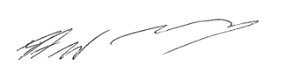

Councillor John Walker
Mayor of Alfreton

ORDER OF BUSINESS

- To hear an address from Councillor John Walker, Town Mayor
- To receive the Town Mayor’s Annual Report
- To read and consider the minutes of the Annual Parish Meeting 2022
- To receive a report on the finances of Alfreton Town Council.
- To hear items from members of the public

