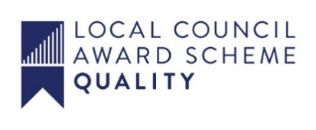
ALFRETON TOWN COUNCIL

MINUTES OF THE EVENTS COMMITTEE MEETING
HELD ON WEDNESDAY
19TH OCTOBER 2022 AT 7PM

EVENTS COMMITTEE

#

Present:
Chairman: Councillor Hannah Jowett-Frost
Members: David Taylor, Mary Kerry

25/22x To receive apologies for absence
Resolved
Apologies were received from Councillor David Taylor

26/22x To receive any declarations of interest from Members
There were none

27/22x Public Participation
There were none

28/22x To consider any items which should be taken in exclusion of the
press and public
There were none

29/22x To read and consider the minutes of the last meeting
The minutes were read

30/22x To Approve the minutes of the last meeting as a correct record
RESOLVED
The minutes were approved as a correct record

31/22x To review the event scope document – Christmas Lights Switch On
RESOLVED
The document was reviewed and approved
That available store are advertised on Severn Square

32/22 To confirm the plan for the Christmas Lights Switch On
RESOLVED
The plans were accepted and approved
That options are explored

33/22 To review the risk assessment for the Christmas Lights Switch On
and Remembrance Sunday
RESOLVED
The risk assessments were received and approved for;
Remembrance Sunday
Events
Older people which will be placed on a future Full Council agenda

34/22 To confirm the plans for Remembrance Sunday
RESOLVED
The notes from the meetings held on 11th and 13th were accepted

35/22 To consider the Party in the Town/Big Summer Event 2023
RESOLVED
That ATC work with SISU and the Cricket Club to provide a Big Summer Event on 8th July 2022 in and across town
- White post farm
- Road closure across the High Street
- Puppet display
- Sarah Bright
- Teddy bears picnic
- Prepare a scope document

Items for the next agenda;
Budgets 22/23 and 23/24
Free/low cost activities for the 6 weeks holidays
Open/best gardens
Allotment week
Records Fair

