ALFRETON TOWN COUNCIL
Rodgers Lane, Alfreton, Derbyshire DE55 7FF. Telephone 01773 520032

AGENDA

REGENERATION COMMITTEE

#

Regeneration Committee 03/03/23

Chair of Committee: Councillor D Taylor
Councillors: M Bennett, M Kerry, H Jowett-Frost, S Marshall-Clarke

On 9th March 2023 at 6.30pm

Room 1, Alfreton House, High Street, Alfreton, Derbyshire, DE55 7HH

All Members of the Committee are requested to attend for the purpose of considering and resolving the business to be transacted as set out in the following agenda.
Yours sincerely
Tina Crookes
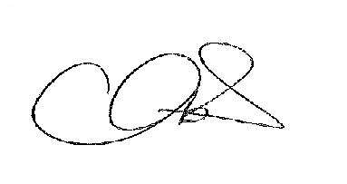
Town Clerk

ORDER OF BUSINESS

25/22r To receive apologies for absence

26/22r To receive any declarations of interest from Members

27/22r Public Participation

28/22r To consider any items which should be taken in exclusion of the
press and public

29/22r To read and consider the minutes of the last meeting

30/22r To Approve the minutes of the last meeting as a correct record

31/22r An update on progress so far
- Arts Trail
- Business Forum
- Interpretation Boards
- Memorial Bench
- Litter Pick
- Phone Box
- Decx – flags and displays

32/22r To approve the umbrella display for 23/24, installation dates and costs split between 2022/23 and 2023/24 budgets

33/22r To approve payments from the Regeneration Budget 22/23
To include;
TocH Lamp and display
Interpretation Board launches
Phone box covers

34/22r To review the budget 23/24

Budget 23/24 | Project
£1000.00 | Membership and advice for market rights
£10,000.00 | Town Brand/Festoons
£2,000.00 | Hanging Baskets
 | Business Forum
 | Artist Trail
 | Phone Box (Arts Trail)
£1,000.00 | Interpretation Boards
 | Memorial Bench
£14,000.00 | TOTAL
Budget | £15,000.00
Underspend from 2022/23 | Balances to be confirmed from 2022/23 budget

Spend to date and planned spend

