ALFRETON TOWN COUNCIL

AGENDA

EVENTS COMMITTEE

#

Events Committee 19/01/2023
Councillors: M Bennett, M Kerry, H Jowett-Frost, S Sounes, D Taylor

On Thursday 26th January at 6PM

Room 1, Alfreton House, High Street, Alfreton, Derbyshire, DE55 7HH

All Members of the Committee are requested to attend for the purpose of considering and resolving the business to be transacted as set out in the following agenda.
Yours sincerely
Tina Crookes
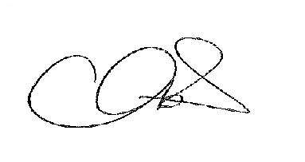
Town Clerk

36/22x To receive apologies for absence

37/22x To receive any declarations of interest from Members

38/22x Public Participation

39/22x To consider any items which should be taken in exclusion of the
press and public

40/22x To read and consider the minutes of the last meeting

41/22x To Approve the minutes of the last meeting as a correct record

42/22x To consider events for 2023/24 Financial Year
Civic Service
Alfreton Big Summer event
Alfreton in Bloom/Open Gardens
Allotment Day
Remembrance Sunday
Christmas Event
Santa Day – visit schools
Breakfast with Santa

43/22 To consider the budget for 2023/24 Financial Year and allocation to each event

