ALFRETON TOWN COUNCIL
Rodgers Lane, Alfreton, Derbyshire DE55 7FF. Telephone 01773 520032

AGENDA

REGENERATION COMMITTEE

#

Regeneration Committee 19/01/2023

Chair of Committee: Councillor D Taylor
Councillors: M Bennett, M Kerry, H Jowett-Frost, S Marshall-Clarke

On Thursday 26th January 2022 at 7PM

Room 1, Alfreton House, High Street, Alfreton, Derbyshire, DE55 7HH

All Members of the Committee are requested to attend for the purpose of considering and resolving the business to be transacted as set out in the following agenda.
Yours sincerely
Tina Crookes
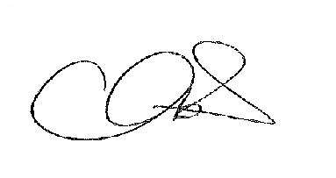
Town Clerk

ORDER OF BUSINESS

16/22r To receive apologies for absence

17/22r To receive any declarations of interest from Members

18/22r Public Participation

19/22r To consider any items which should be taken in exclusion of the
press and public

20/22r To read and consider the minutes of the last meeting

21/22r to Approve the minutes of the last meeting as a correct record

22/22r An update on progress so far
- Arts Trail
- Business Forum
- Interpretation Boards
- Memorial Bench
- Litter Pick
- Phone Box
- Decx – flags and displays

23/22r To receive an update on the budget 22/23

£1,000.00 | Membership and advice for market rights
£1,000.00 | Town Brand
£6,500.00 | Business inclusion/Planters/Town centre improvements
 | · Flags Hanging Baskets
£200.00 | Business Forum
£2,800.00 | Artist Trail
£500.00 | Phone Box (Arts Trail)
£1,000.00 | Interpretation Boards
£1,000.00 | Memorial Bench
£14,000.00 | TOTAL
Budget | £15,000.00
Underspend from 2021/22 | £4,000.00 in balances to be confirmed for 2022/23 budget

24/22r To consider the budget for 2023/24 and projects

