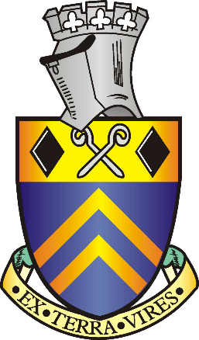

FRACKING COMMITTEE MEETING 02.02.16

Attendees: J Walker, S Walker, K Wood and J Smith

- Apologies for absence
None

- To receive an email received from INEOS
INEOS have offered to meet with the Council about the concepts of Fracking

- To establish issues surrounding Fracking in Alfreton
Open Spaces to Frack in
Pollution
Earthquakes
Ex-Mining area
Logistics of equipment through Town
Contamination of water and flooding issues

RECOMMENDATION
That due to uncertainty and concerns nationally along with economical issues the Town Council will have a policy to oppose fracking requests in Alfreton – will consider unbiased reports to review this policy in the future

