ALFRETON TOWN COUNCIL

AGENDA

EVENTS COMMITTEE

#

Events Committee
Councillors: M Bennett, M Kerry, H Jowett-Frost, S Sounes, D Taylor

On Monday 19th October 2022 at 7PM

Room 1, Alfreton House, High Street, Alfreton, Derbyshire, DE55 7HH

All Members of the Committee are requested to attend for the purpose of considering and resolving the business to be transacted as set out in the following agenda.
Yours sincerely
Tina Crookes
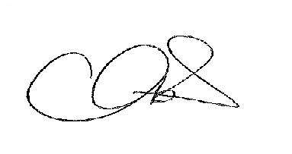
Town Clerk

25/22x To receive apologies for absence

26/22x To receive any declarations of interest from Members

27/22x Public Participation

28/22x To consider any items which should be taken in exclusion of the
press and public

29/22x To read and consider the minutes of the last meeting

30/22x To Approve the minutes of the last meeting as a correct record

31/22x To review the event scope document – Christmas Lights Switch On

32/22 To confirm the plan for the Christmas Lights Switch On

33/22 To review the risk assessment for the Christmas Lights Switch On
and Remembrance Sunday

34/22 To confirm the plans for Remembrance Sunday

34/22 To consider the Party in the Town/Big Summer Event 2023

