ALFRETON TOWN COUNCIL

AGENDA

EVENTS COMMITTEE

#

Events Committee
Councillors: M Bennett, M Kerry, H Jowett-Frost, S Sounes, D Taylor

On Monday 26th September 2022 at 6PM

Room 1, Alfreton House, High Street, Alfreton, Derbyshire, DE55 7HH

All Members of the Committee are requested to attend for the purpose of considering and resolving the business to be transacted as set out in the following agenda.
Yours sincerely
Tina Crookes
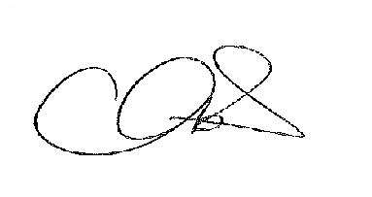
Town Clerk

14/22x To receive apologies for absence

15/22x To receive any declarations of interest from Members

16/22x Public Participation

17/22x To consider any items which should be taken in exclusion of the
press and public

18/22x To review the event scope document

19/22 To confirm entertainment

20/22 To confirm stalls

21/22 Review risk assessment

22/22 Plan member and staff availability

23/22 To consider a budget for a Party in the Town/Mayor Day and date
- To confirm underspend 2021/2022 and adjustment required for 2022/2023 budget

