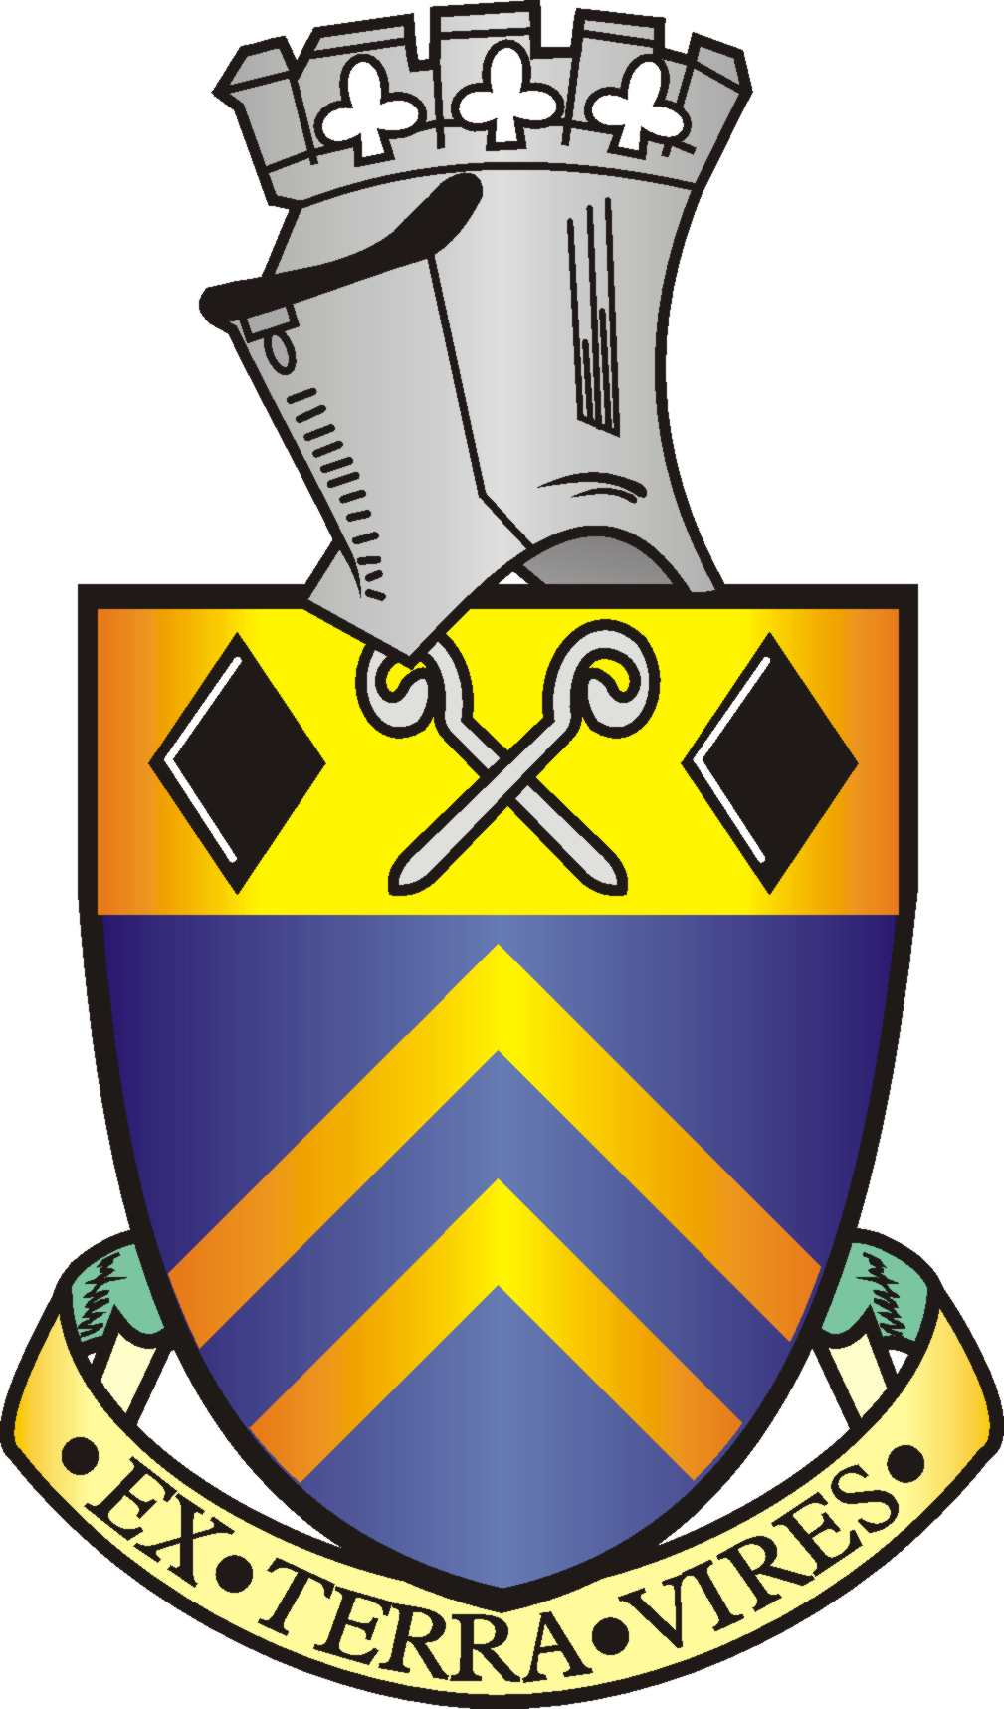

MINUTES OF THE PARISH MEETING OF ALFRETON 17TH MAY 2022 AT 6.30PM.
ROOM 1, ALFRETON HOUSE, HIGH STREET, ALFRETON, DERBYSHIRE, DE55 7HH

Alfreton Town Council

ORDER OF BUSINESS

Present: Councillor S Marshall-Clarke and 9 electors

1. To hear an address from Councillor Steve Marshall-Clarke, Town Mayor
The Meeting heard an address from Councillor Marshall-Clarke in his year as Town Mayor. Councillor Marshall-Clarke thanked colleagues and staff for their support during a particularly difficult year in office due to Covid. He also thanked all the people who had supported his nominated charity Derbyshire Childrens Holiday Centre, a cheque will be presented at a future meeting once the final total has been received.

2. To receive the Town Mayor’s Annual Report
Due to staffing shortages the report will be available at a future meeting

3. To read and consider the minutes of the Annual Parish Meeting 2021
The Minutes were read and approved as a correct record

4. To receive a report on the finances of Alfreton Town Council.
The accounts were received and approved

5. To hear items from members of the public
There were none

