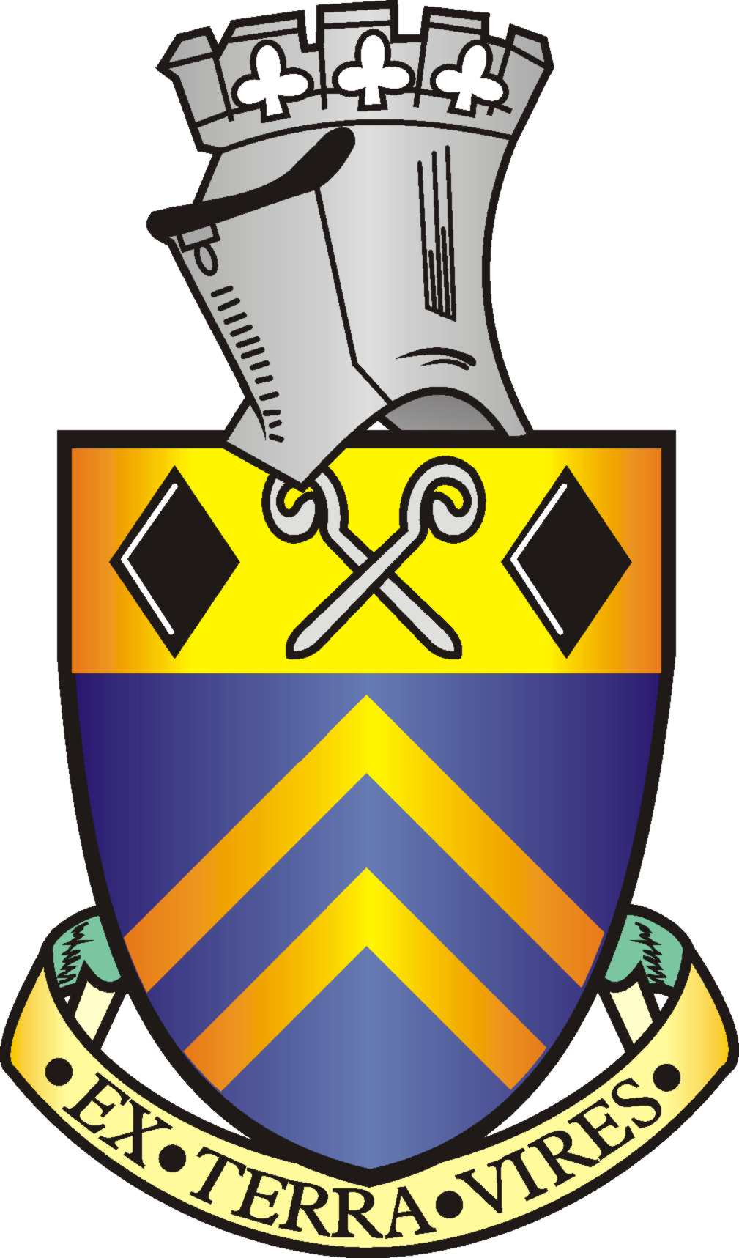

Alfreton Town Council

Minutes of the Full Council meeting held on Tuesday 26th October 2021 at 7pm at Room 1, Alfreton House, High Street, Alfreton.

Present:
Town Mayor: Councillor S Marshall-Clarke
Councillors: G Dolman, H Jowett-Frost, M Kerry, A Richardson, C Robinson, D Taylor, K Wood
Officers: V Johnstone

ORDER OF BUSINESS

122/21 To receive apologies for absence
Apologies were received and accepted from Councillors:
M Bennett – Illness
C Dale – Work Commitment
J Walker – Personal
S Walker – Work Commitment

123/21 To receive any declarations of interest from Members
There were none

124/21 Recording and Filming of Council and Committee Meetings
Noted

125/21 Public Participation
There were none

126/21 To consider any items which should be taken in exclusion of the press and public
There were none

127/21 To consider and approve the Minutes of the Regeneration Working Group Meeting held on 4th October 2021 and receive an update on Regeneration & Welcome Back Fund. That spend is approved within the given budgets £17,500 and £30,000 WBF.
RESOLVED
1. The minutes were approved as a correct record
2. That the update is noted, members would like to explore the appointment of legal services to identify how to have the market charter removed, a report will be bought to a future meeting
3. To explore the idea of an Ice rink & Big wheel under the WBF
4. That spend is approved within the given budgets £17,500 and £30,000 WBF.

