Alfreton Town Council

Agenda 15th February 2022

Rodgers Lane,
Alfreton,
Derbyshire DE55 7FF
Telephone
01773 520032

Town Mayor and
Elected Members
Alfreton Town Council.

3rd February 2022
Dear Member,

I hereby give you notice that the next meeting of the Full Council will be held at
on: Tuesday 15th February 2022 Woodbridge Junior School, Grange Street, Alfreton, DE55 7JA

All Members of the Council are summoned to attend for the purpose of considering and resolving the business to be transacted as set out in the following agenda.

Yours sincerely,
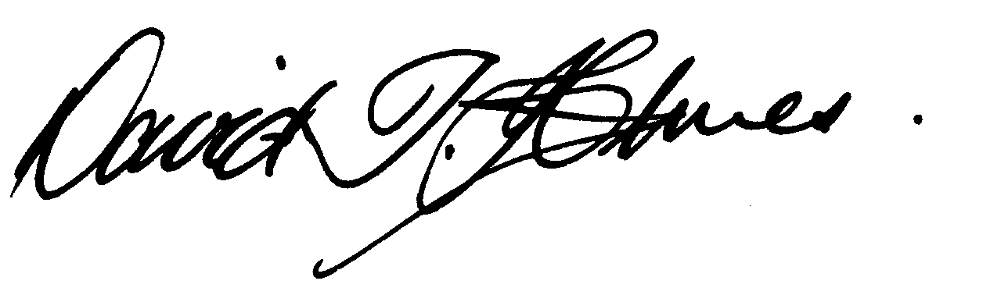
David T Holmes,
Joint Town Clerk

MEETING OF ALFRETON TOWN COUNCIL

ORDER OF BUSINESS

01/22 To receive apologies for absence

02/22 To receive any declarations of interest from Members
Members are requested to declare the existence and nature of any disclosable pecuniary interest and/or other interest, not already on their register of interests, in any item on the agenda and withdraw from the meeting at the appropriate time, or to request a dispensation. Please note that appropriate forms should be completed prior to commencement of the meeting.

03/22 Recording and Filming of Council and Committee Meetings
The right to record, film and to broadcast meetings of the council and committees is established following the Local Government Audit and Accountability Act 2014. This is in addition to the rights of the press and public to attend such meetings. Meetings or parts of the meetings from which the press and public are excluded may not be filmed or recorded. Members of the public are permitted to film or record meetings to which they are permitted access, in a non-disruptive manner.

04/22 Public Participation
The period of time designated for public participation at a meeting shall not exceed 20 minutes, a member of the public shall not speak for more than 3 minutes, unless directed by the Town Mayor of the meeting.
A question may only be asked if notice has been given by delivering it in writing or e-mail to the Town Clerk 7 clear days before the meeting, unless the Town Mayor regards it as urgent in his opinion.
A separate public participation procedure exists.
Link to Alfreton Town Council policies and procedures

05/22 To consider any items which should be taken in exclusion of the press and public
If the Council decides to exclude the press and public it will be necessary to pass a resolution in the following terms:- “That in view of the confidential nature of the business about to be transacted, to consider a resolution to exclude the Press and Public from the meeting in accordance with the Public Bodies (Admission to Meetings) Act 1960, s1, in order to discuss the item. A reason must be stated
Item 11/22 g. To receive a report on staffing matters due to GDPR

06/22 To hear from a representative of Derbyshire Police should one be available
- To hear a response from Derbyshire Police regarding Remembrance Sunday and the comparative service (if any) with the Chesterfield Remembrance Sunday

07/22 To read and consider the Minutes of the Meeting of Alfreton Town Council held on Tuesday 18th January 2022 copies have been circulated to each Member with the summons to attend the meeting; the Minutes may be taken as read.

08/22 After consideration to approve the signature of the Meeting Minutes of Tuesday 18th January 2022 by the person presiding as a correct record

09/22 To dispose of business, if any, remaining from the last meeting
There are none

10/22 To receive and consider reports and minutes of committees

11/22 To receive and consider additional agenda items in the order in which they have been notified.

- Recycling collection service in Alfreton – Verbal report
- Potential Close of the B&M store and its effect on the Severn Square car park and area – Verbal report
- The Parkwood Training Centre
- Road Safety in Alfreton in particular traffic regulation orders
- Complaint regarding Road Surfacing in Nottingham Road
- To consider the award of a grant to SISU for provision of a Community Hub (report to follow)
- To receive a report on staffing matters to be heard in exclusion

12/22 To authorise the signing of orders for payment

December 2021 £41,941.58
January 2022 £27,613.21

13/22 To receive reports from Members who may have attended Outside Bodies meetings
ACTS - Councillor Marlene Bennett
Alfreton Community Forum – Councillor Mary Kerry
Alfreton Heritage – Councillor Keith Wood
Amber Valley Access – Councillor Cheryl O’Brien
Pub Watch – Councillor Marlene Bennett
Derbyshire Unemployed Workers – Councillors Steve Marshall-Clarke & Mary Kerry
Alfreton Community Hall – Councillor Scott Walker or nominee
Pentrich Revolution – Councillor Keith Wood
Police Forum – Councillor Steve Marshall-Clarke

14/22 To consider 4 topics for communication

15/22 To review and approve the following policies:
a. Communication Protocol
b. House of Confinement – Access Guidelines
c. Planning Procedures

16/22 To ratify Planning Applications:

Consultation Date - 7/Dec/2021
Ref: AVA/2021/1251
Address: 211 Nottingham Road, Alfreton, Derbyshire, DE55 7FL
Proposal: installation of drop kerbs and removal of boundary wall to enable vehicle access to the front garden
Date Valid: 7/Dec/2021
Decision Expected:25/Jan/2022
Decision Issued:11/Jan/2022

Consultation Date - 4/Jan/2022
Ref: AVA/2021/1221
Address: Munch Kitchen Ltd, 87 High Street, Alfreton, Derbyshire, DE55 7DP
Proposal: Change of use from restaurant E(b) to hot food takeaway (sui generis)
Date Valid: 23/Dec/2021
Decision Expected:10/Feb/2022

Consultation Date - 21/Jan/2022
Ref: AVA/2022/0041
Address: Land South Of Mansfield Road And North Of A38, Mansfield Road, Alfreton, Derbyshire
Proposal: Non material amendment to AVA/2015/0977 for minor adjustments to the layout of plots 304-308 (House types remain unaltered)
Date Valid:21/Jan/2022
Decision Expected:11/Feb/2022

Consultation Date - 24/Jan/2022
Ref: AVA/2022/0048
Address: 11 Charles Street, Alfreton, Derbyshire, DE55 7EA
Proposal: Removal of conditon 1 of AVA/2020/1071 which states the use of the hereby approved building for a personal training business is valid for a limited period only, expiring on 30 June 2022
Date Valid: 24/Jan/2022
Decision Expected:14/Mar/2022

Consultation Date - 26/Jan/2022
Ref: AVA/2022/0059
Address: 89 Mansfield Road, Alfreton, Derbyshire, DE55 7JP
Proposal: Conversion of vacant 3 bedroomed house into 7 bedroomed HMO by means of internal alterations, single storey side extension & single storey dormer extension to the rear
Date Valid:26/Jan/2022
Decision Expected:16/Mar/2022

Planning Application decisions

Decision Date - 16/Dec/2021
Ref: AVA/2021/0894
Address: Land Adj 77 Flowery Leys Lane, Flowery Leys Lane, Alfreton, Derbyshire, Proposal: New two storey detached 3-bedroom dwelling
Date Registered:3/Sep/2021
Decision: REFUSED

Decision Date - 14/Jan/2022
Ref: AVA/2021/0607
Address: Land To West Of Richford Motor Factors, Dunsford Road, Alfreton, Derbyshire
Proposal: Demolition of existing office and storage containers to be replaced by a new office/workshop building
Date Registered: 28/Sep/2021
Decision: PERMITTED

Decision Date - 5/Jan/2022
Ref: AVA/2021/1009
Address: Price Less, 88 High Street, Alfreton, Derbyshire, DE55 7BE
Proposal: Change of use from retail unit to 5 No. apartments with retention of 1 No. ground floor retail unit to frontage
Date Registered:24/Sep/2021
Decision: PERMITTED

Decision Date - 16/Dec/2021
Ref: AVA/2021/1227
Address: 6 Nuttall Street, Alfreton, Derbyshire, DE55 7AY
Proposal: Proposed single storey extension to rear of existing dwelling
Date Registered:18/Nov/2021
Decision: PERMITTED

Decision Date - 8/Dec/2021
Ref: AVA/2021/1236
Address: Land At Alfreton Park, Alfreton Park, Alfreton, Derbyshire,
Proposal: Request for comments on DCC application code CD6/1021/21 for variation of condition 1 of CD6/0820/32
Date Registered:19/Nov/2021
Applicant: Development Management Derbyshire County Council, County Hall, Matlock, Derbyshire, DD4 3AG
Decision: Comment Made

Decision Date - 11/Jan/2022
Ref: AVA/2021/1251
Address: 211 Nottingham Road, Alfreton, Derbyshire, DE55 7FL
Proposal: installation of drop kerbs and removal of boundary wall to enable vehicle access to the front garden
Date Registered: 7/Dec/2021
Decision: PERMITTED

Date of next meeting: 15th March 2022

