ALFRETON TOWN COUNCIL
Rodgers Lane, Alfreton, Derbyshire DE55 7FF. Telephone 01773 520032

AGENDA 17th February 2022

REGENERATION WORKING GROUP

#

Regeneration Working Group 09/02/2022

Councillors: M Bennett, M Kerry, H Jowett-Frost, S Marshall Clarke, D Taylor

Notice that the next meeting of the Regeneration working group will be held at Room 1 Alfreton House

on: Thursday 17th February 2022 at 6pm

All Members of the working group are requested to attend for the purpose of considering and resolving the business to be transacted as set out in the following agenda.

Yours sincerely

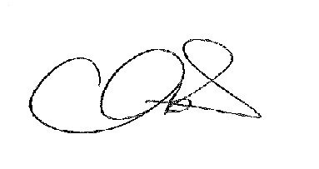

Tina Crookes
Joint Town Clerk

01/22r To receive apologies for absence

02/22r To receive any declarations of interest from Members

03/22r Public Participation

04/22r To consider any items which should be taken in exclusion of the
press and public

05/22r To receive an update on the Regeneration Plan
- Town Map update (£80.00 additional photographs)
- Flags
- Litter picks
- Insurance (£57.79)
- Interpretation Boards
- WBF overspend (£2547.90)
- Amberol buy-back (£546.05 )
- Planters – compost (£155.78)

06/22r To receive an update on the WBF Plan
- Canopy costs (£4995 & £9995)
- Planting costs
- Balance

