Alfreton Town Council

Agenda 18th January 2022

Rodgers Lane,
Alfreton,
Derbyshire DE55 7FF
Telephone
01773 520032

Town Mayor and
Elected Members
Alfreton Town Council.

11th January 2022
Dear Member,

I hereby give you notice that the next meeting of the Full Council will be held at Alfreton Leisure Centre (Meeting room adjacent to the Bowls Hall) Church Street, Alfreton, DE55 7BD

on: Tuesday 18th January 2022 at 7:00pm

All Members of the Council are summoned to attend for the purpose of considering and resolving the business to be transacted as set out in the following agenda.

Yours sincerely,
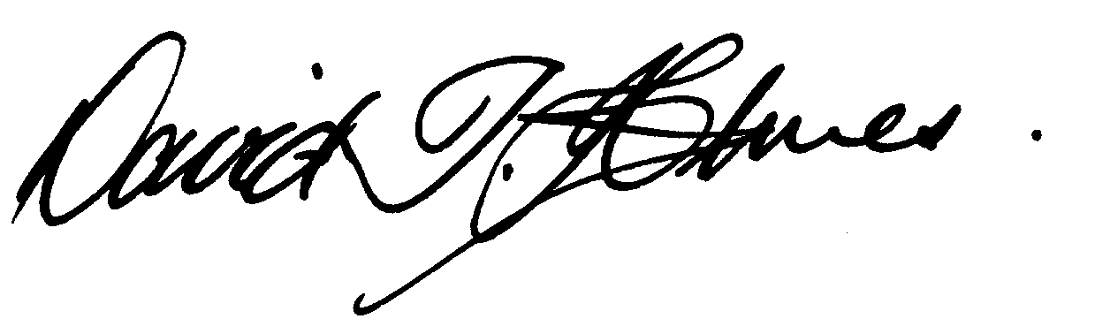
David T Holmes,
Joint Town Clerk

MEETING OF ALFRETON TOWN COUNCIL

ORDER OF BUSINESS

144/21 To receive apologies for absence

145/21 To receive any declarations of interest from Members
Members are requested to declare the existence and nature of any disclosable pecuniary interest and/or other interest, not already on their register of interests, in any item on the agenda and withdraw from the meeting at the appropriate time, or to request a dispensation. Please note that appropriate forms should be completed prior to commencement of the meeting.

146/21 Recording and Filming of Council and Committee Meetings
The right to record, film and to broadcast meetings of the council and committees is established following the Local Government Audit and Accountability Act 2014. This is in addition to the rights of the press and public to attend such meetings. Meetings or parts of the meetings from which the press and public are excluded may not be filmed or recorded. Members of the public are permitted to film or record meetings to which they are permitted access, in a non-disruptive manner.

147/21 Public Participation
The period of time designated for public participation at a meeting shall not exceed 20 minutes, a member of the public shall not speak for more than 3 minutes, unless directed by the Town Mayor of the meeting.
A question may only be asked if notice has been given by delivering it in writing or e-mail to the Town Clerk 7 clear days before the meeting, unless the Town Mayor regards it as urgent in his opinion.
A separate public participation procedure exists.
Link to Alfreton Town Council policies and procedures

148/21 To consider any items which should be taken in exclusion of the press and public
If the Council decides to exclude the press and public it will be necessary to pass a resolution in the following terms:- “That in view of the confidential nature of the business about to be transacted, to consider a resolution to exclude the Press and Public from the meeting in accordance with the Public Bodies (Admission to Meetings) Act 1960, s1, in order to discuss the item. A reason must be stated

- Item 154/21b To receive a report on pay grades and proposed increments following successful completion of Community Governance – Item to be heard in exclusion – due to GDPR and confidential nature
- Item 154/21d To receive a report on rental increases for tenants in Alfreton House and allotments

149/21 To hear from a representative of Derbyshire Police should one be available

To receive a response from Sergeant Bowler regarding Remembrance Sunday

150/21 To read and consider the Minutes of the Meeting of Alfreton Town Council held on Tuesday 16th November 2021 copies have been circulated to each Member with the summons to attend the meeting; the Minutes may be taken as read.

151/21 After consideration to approve the signature of the Meeting Minutes of Tuesday 16th November 2021 by the person presiding as a correct record

152/21 To dispose of business, if any, remaining from the last meeting
There are none

153/21 To receive and consider reports and minutes of committees
- To receive the notes of the regeneration working party held on 7th December 2021 and to approve the recommendations made

154/21 To receive and consider additional agenda items in the order in which they have been notified.

- To receive a report to appoint an Internal Auditor 2022
- To receive a report on pay grades and proposed increments following successful completion of Community Governance – Item to be heard in exclusion
- To review the Christmas Lights Switch on Event 2021 and produce a lessons learnt document
- To receive a report on rental increases for tenants in Alfreton House and allotments
- To receive a response regarding Environmental Matters from AVBC
- To receive an update of further changes to East Midlands Railway services (awaiting confirmation from EMR)
- To receive a grant application from;
  - Derbyshire Unemployed Workers Centre (DUWC) for £5,000.00
h. To set a budget and subsequent precept for the financial year 2022/2023

155/21 To authorise the signing of orders for payment

November £18,782.50

- That Lead and Support Members approve the spend allocated to budget (Nominal Code)

156/21 To receive reports from Members who may have attended Outside Bodies meetings
ACTS - Councillor Marlene Bennett
Alfreton Community Forum – Councillor Mary Kerry
Alfreton Heritage – Councillor Keith Wood
Amber Valley Access – Councillor Cheryl O’Brien
Pub Watch – Councillor Marlene Bennett
Derbyshire Unemployed Workers – Councillors Steve Marshall-Clarke & Mary Kerry
Alfreton Community Hall – Councillor Scott Walker or nominee
Pentrich Revolution – Councillor Keith Wood
Police Forum – Councillor Steve Marshall-Clarke

157/21 To consider 4 topics for communication

158/21 To review and approve the following policies:
- Fire Risk Assessment
- Risk Management Policy
- Grievance Procedure
- Equal Opportunities Policy

159/21 To ratify Planning Applications:

- To receive a response from AVBC on lorries parked by Tesco
Planning Application decisions

Consultation Date - 10/Nov/2021
Ref: AVA/2021/1147
Address: Protective Polymers, Unit 39, Lydford Road, Alfreton, Derbyshire, DE55 7RQ
Proposal: Construction of a Steel portal frame building for warehouse and storage usage.
Date Valid: 9/Nov/2021
Decision Expected: 28/Dec/2021

Consultation Date - 18/Nov/2021
Ref: AVA/2021/1227
Address: 6 Nuttall Street, Alfreton, Derbyshire, DE55 7AY
Proposal: Proposed single storey extension to rear of existing dwelling
Date Valid:18/Nov/2021
Decision Expected: 6/Jan/2022

Consultation Date - 19/Nov/2021
Ref: AVA/2021/1236
Address: Land At Alfreton Park, Alfreton Park, Alfreton, Derbyshire Proposal: Request for comments on DCC application code CD6/1021/21 for variation of conditon 1 of CD6/0820/32
Date Valid: 19/Nov/2021
Decision Expected: 10/Dec/2021

Consultation Date - 1/Dec/2021
Ref: AVA/2021/1196
Address: 9 Oak Drive, Alfreton, Derbyshire, DE55 7EY
Proposal: Proposed bungalow on land adjacent to 9 Oak Drive, Alfreton
Date Valid: 1/Dec/2021
Decision Expected: 19/Jan/2022

Planning Application decisions

Decision Date - 5/Nov/2021
Ref: AVA/2021/1029
Address: 41 Wycliffe Road, Alfreton, Derbyshire, DE55 7HR
Proposal: Proposed 2.5 storey rear extension and a single storey side extension
Date Registered:29/Sep/2021
Decision: PERMITTED

Decision Date - 5/Nov/2021
Ref: AVA/2021/1025
Address:1 - 3 High Street, Alfreton, Derbyshire, DE55 7DR
Proposal: Proposed change of use of first and second floor office accommodation to form 2no. self contained flats
Date Registered: 17/Sep/2021
Decision: PERMITTED

Decision Date - 18/Nov/2021
Ref: AVA/2021/0667
Address: 47 Damstead Park Avenue, Alfreton, Derbyshire, DE55 7PR
Proposal: Engineering operation for levelling of existing garden
Date Registered:9/Jun/2021
Decision: PERMITTED

Decision Date - 1/Nov/2021
Ref: AVA/2021/0693
Address: Land At Copthorne Drive, Eachwell Lane, Alfreton, Derbyshire
Proposal: Erection of single dwelling and associated infrastructure
Date Registered:18/Jun/2021
Decision: PERMITTED

Decision Date - 23/Nov/2021
Ref: AVA/2021/0700
Address: The Grange, Marshall Street, Alfreton, Derbyshire, DE55 7BW
Proposal: Change of use from childrens day nursery (use class E(f) to 8 bedroomed HMO (sui generis) with internal layout changes
Date Registered:18/Jun/2021
Decision: PERMITTED

Decision Date - 7/Dec/2021
Ref: | AVA/2020/1224
Address: | Hall Farm, Church Street, Alfreton, Derbyshire, DE55 7AH,
Proposal: | Proposed development of a photovoltaic solar park and associated infrastructure.
Date Registered: | 7/Jan/2021
Decision: | REFUSED

Date of next meeting: 15th February 2022

