Alfreton Town Council

Agenda 26th October 2021

Rodgers Lane,
Alfreton,
Derbyshire DE55 7FF
Telephone
01773 520032
Town Mayor and
Elected Members
Alfreton Town Council.

20th October 2021
Dear Member,

I hereby give you notice that the next meeting of the Full Council will be held at the Council Chamber, Room 1 Alfreton House, High Street, Alfreton

on: Tuesday 26th October 2021 at 7:00pm

All Members of the Council are summoned to attend for the purpose of considering and resolving the business to be transacted as set out in the following agenda.

Yours sincerely,
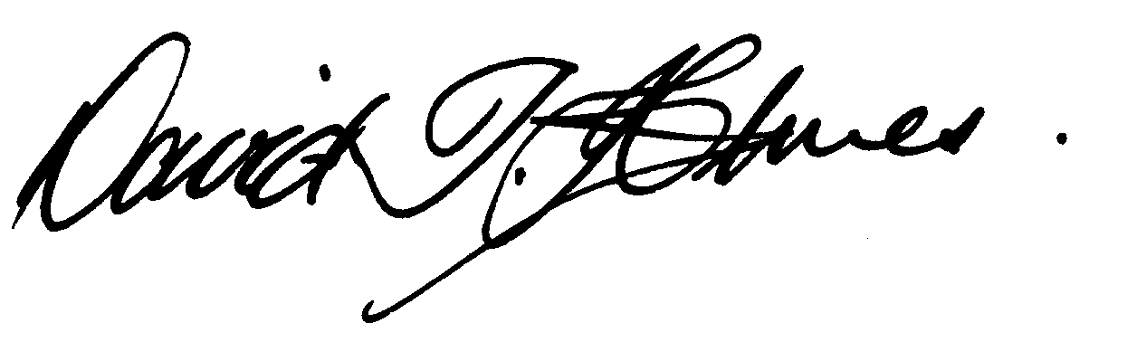
David T Holmes,
Joint Town Clerk

MEETING OF ALFRETON TOWN COUNCIL

ORDER OF BUSINESS

116/21 To receive apologies for absence

117/21 To receive any declarations of interest from Members
Members are requested to declare the existence and nature of any disclosable pecuniary interest and/or other interest, not already on their register of interests, in any item on the agenda and withdraw from the meeting at the appropriate time, or to request a dispensation. Please note that appropriate forms should be completed prior to commencement of the meeting.

118/21 Recording and Filming of Council and Committee Meetings
The right to record, film and to broadcast meetings of the council and committees is established following the Local Government Audit and Accountability Act 2014. This is in addition to the rights of the press and public to attend such meetings. Meetings or parts of the meetings from which the press and public are excluded may not be filmed or recorded. Members of the public are permitted to film or record meetings to which they are permitted access, in a non-disruptive manner.

119/21 Public Participation
The period of time designated for public participation at a meeting shall not exceed 20 minutes, a member of the public shall not speak for more than 3 minutes, unless directed by the Town Mayor of the meeting.
A question may only be asked if notice has been given by delivering it in writing or e-mail to the Town Clerk 7 clear days before the meeting, unless the Town Mayor regards it as urgent in his opinion.
A separate public participation procedure exists.
Link to Alfreton Town Council policies and procedures

120/21To consider any items which should be taken in exclusion of the press and public
If the Council decides to exclude the press and public it will be necessary to pass a resolution in the following terms:- “That in view of the confidential nature of the business about to be transacted, to consider a resolution to exclude the Press and Public from the meeting in accordance with the Public Bodies (Admission to Meetings) Act 1960, s1, in order to discuss the item. A reason must be stated
There are none recommended

121/21

An item deferred from the Town Council meeting held on 19 October 2021
To consider and approve the Minutes of the Regeneration Working Group Meeting held on 4th October 2021 (copy enclosed) and receive an update on Regeneration/ Welcome Back Fund. That spend is approved within the given budgets £17,500.00 and £30,000.00 WBF.

