Alfreton Town Council

Agenda 16th November 2021

Rodgers Lane,
Alfreton,
Derbyshire DE55 7FF
Telephone
01773 520032

Town Mayor and
Elected Members
Alfreton Town Council.

4th November 2021
Dear Member,

I hereby give you notice that the next meeting of the Full Council will be held at Woodbridge Junior School, Grange Street, Alfreton, DE55 7JA

on: Tuesday 16th November 2021 at 7:00pm

All Members of the Council are summoned to attend for the purpose of considering and resolving the business to be transacted as set out in the following agenda.

Yours sincerely,
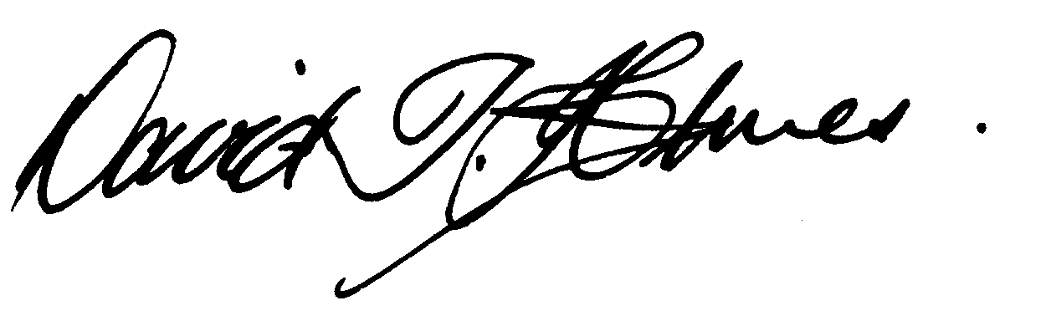
David T Holmes,
Joint Town Clerk

MEETING OF ALFRETON TOWN COUNCIL

ORDER OF BUSINESS

128/21 To receive apologies for absence

129/21 To receive any declarations of interest from Members
Members are requested to declare the existence and nature of any disclosable pecuniary interest and/or other interest, not already on their register of interests, in any item on the agenda and withdraw from the meeting at the appropriate time, or to request a dispensation. Please note that appropriate forms should be completed prior to commencement of the meeting.

130/21 Recording and Filming of Council and Committee Meetings
The right to record, film and to broadcast meetings of the council and committees is established following the Local Government Audit and Accountability Act 2014. This is in addition to the rights of the press and public to attend such meetings. Meetings or parts of the meetings from which the press and public are excluded may not be filmed or recorded. Members of the public are permitted to film or record meetings to which they are permitted access, in a non-disruptive manner.

131/21 Public Participation
The period of time designated for public participation at a meeting shall not exceed 20 minutes, a member of the public shall not speak for more than 3 minutes, unless directed by the Town Mayor of the meeting.
A question may only be asked if notice has been given by delivering it in writing or e-mail to the Town Clerk 7 clear days before the meeting, unless the Town Mayor regards it as urgent in his opinion.
A separate public participation procedure exists.
Link to Alfreton Town Council policies and procedures

132/21 To consider any items which should be taken in exclusion of the press and public
If the Council decides to exclude the press and public it will be necessary to pass a resolution in the following terms:- “That in view of the confidential nature of the business about to be transacted, to consider a resolution to exclude the Press and Public from the meeting in accordance with the Public Bodies (Admission to Meetings) Act 1960, s1, in order to discuss the item. A reason must be stated

Item 138/21 c. To consider quotations for the Winter Bedding Scheme due to commercial sensitivity

133/21 To hear from a representative of Derbyshire Police should one be available

134/21 To read and consider the Minutes of the Meeting of Alfreton Town Council held on Tuesday 19th October 2021 & Tuesday 26th October 2021 copies have been circulated to each Member with the summons to attend the meeting; the Minutes may be taken as read.

135/21 After consideration to approve the signature of the Meeting Minutes of Tuesday 19th October 2021 & Tuesday 26th October 2021 by the person presiding as a correct record

136/21 To dispose of business, if any, remaining from the last meeting
There are none

137/21 To receive and consider reports and minutes of committees
a. Christmas Lights Committee

138/21 To receive and consider additional agenda items in the order in which they have been notified.

a. To receive a grant application from SISU for the Community Hub (details to follow)
b. To consider a request for sponsorship from Alfreton Town Football Club
c. To consider quotations for the Winter Bedding Scheme

139/21 To authorise the signing of orders for payment

October £17,907.26

140/21 To receive reports from Members who may have attended Outside Bodies meetings

ACTS - Councillor Marlene Bennett
Alfreton Community Forum – Councillor Mary Kerry
Alfreton Heritage – Councillor Keith Wood
Amber Valley Access – Councillor Cheryl O’Brien
Pub Watch – Councillor Marlene Bennett
Derbyshire Unemployed Workers – Councillors Steve Marshall-Clarke & Mary Kerry
Alfreton Community Hall – Councillor Scott Walker or nominee
Pentrich Revolution – Councillor Keith Wood
Police Forum – Councillor Steve Marshall-Clarke

141/21 To consider 4 topics for communication

142/21 To review and approve the following policies:
a. Complaints Procedure
b. Disciplinary Procedure
c. Grant, Sport & Social Policy
d. Public Participation

143/21 To ratify Planning Applications:

See attached email – | Proposed Bluebells Retirement Village
Planning Application decisions

Decision Date - 20/Oct/2021
Ref: AVA/2021/0951
Address:100 Nottingham Road, Alfreton, Derbyshire, DE55 7GL
Proposal: Proposed two storey side extension and 2 single storey rear extensions
Date Registered: 25/Aug/2021
Decision: PERMITTED

Decision Date - 22/Oct/2021
Ref: AVA/2019/0709
Address: David Nieper Academy, Derbyshire County Council, Grange Street, Alfreton, Derbyshire, DE55 7JA
Proposal: Variation of condition 2 (approved plans) of CD6/0315/157 to change approved levels, buildings and layout of approved Academy
Date Registered:16/Jul/2019
Decision: PERMITTED

Decision Date - 28/Oct/2021
Ref: AVA/2021/0693
Address: Land At Copthorne Drive, Eachwell Lane, Alfreton, Derbyshire, Proposal: Erection of single dwelling and associated infrastructure
Date Registered:18/Jun/2021
Decision: Pending

Decision Date - 30/Sep/2021
Ref: AVA/2019/1195
Address: The Kings Banqueting Hall, Chesterfield Road, Alfreton, Derbyshire, DE55 7DT
Proposal: Variation of condition 2 of AVA/2018/0556 to agree new internal layout and external alterations of approved flats and restaurant
Date Registered:18/Feb/2020
Decision: PERMITTED

Decision Date - 12/Oct/2021
Ref: AVA/2021/0313
Address: Land North Of Alfreton (South Of B6025), Meadow Lane, Alfreton, Derbyshire
Proposal: Construction of a 19.657MW Solar Farm for a period of 40 years, to include the installation of Solar Panels with transformers, a substation, a DNO control room, a customer substation, GRP comms cabin, security fencing, landscaping and other associated infrastructure. This may affect the setting of a listed building
Date Registered: 9/Apr/2021
Decision: PERMITTED

Decision Date - 13/Oct/2021
Ref: AVA/2021/0482
Address: The Glebe, Church Street, Alfreton, Derbyshire, DE55 7AH,Proposal:Conversion of existing care home building (use class C2) to form 17 independent apartments for supported living (use class C2)
Date Registered:18/May/2021
Decision: PERMITTED

Decision Date - 25/Oct/2021
Ref: AVA/2021/1057
Address: Erimar, 17A Wood Street, Alfreton, Derbyshire, DE55 7JW,Proposal:Two storey side extension and single storey rear extension to existing dwelling
Date Registered: 27/Sep/2021
Decision: PERMITTED

Decision Date - 1/Nov/2021
Ref: | AVA/2021/0693
Address: | Land At Copthorne Drive, Eachwell Lane, Alfreton, Derbyshire,
Proposal: | Erection of single dwelling and associated infrastructure.
Date Registered: | 18/Jun/2021
Decision: | PERMITTED

