Alfreton Town Council

NOTICE OF VACANCY IN THE OFFICE OF TOWN COUNCILLOR

NOTICE IS HEREBY GIVEN that a vacancy has occurred in the office of Councillor for the West Ward of the Parish of Alfreton, as a result of the reason of Councillor Ben Slade resigning.

The vacancy will be filled by election if, with 14 days after the date of this notice*, 10 electors for the West Ward give notice in writing to the Electoral Returning Officer, Amber Valley Borough Council, Town Hall, Market Place, Ripley, Derbyshire, DE5 3BT asking for an election to be held to fill the vacancy.

If an election is not requested, the vacancy will be filled by Alfreton Town Council

Dated 24th June 2021
Signed
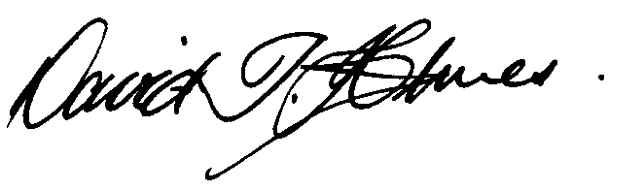
Town Clerk and Proper Officer
*(Note: The period of 14 days referred to EXCLUDES Saturdays, Sundays and Bank
Holidays)

