Alfreton Town Council

Agenda 16th March 2021

Rodgers Lane,
Alfreton,
Derbyshire DE55 7FF
Telephone
01773 520032

Town Mayor and
Elected Members
Alfreton Town Council.

10th March 2021
Dear Member,

I hereby give you notice that the next meeting of the Full Council will be held virtually by Zoom on: Tuesday 16th March 2021 at 7:00pm

All Members of the Council are summoned to attend for the purpose of considering and resolving the business to be transacted as set out in the following agenda.

Arrangements for members of the public - if you would like to join this virtual meeting please email office@alfretontc.co.uk. You will then be sent a link and password which will enable you to join. Unfortunately, this is necessary to prevent ‘trolling’ of the meeting.

Yours sincerely,
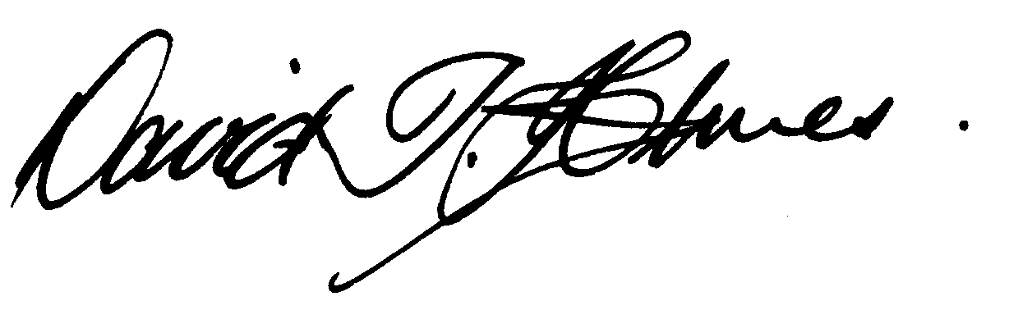
David T Holmes,
Joint Town Clerk

MEETING OF ALFRETON TOWN COUNCIL

ORDER OF BUSINESS

29/21 To receive apologies for absence
Members are requested to declare the existence and nature of any disclosable pecuniary interest and/or other interest, not already on their register of interests, in any item on the agenda and withdraw from the meeting at the appropriate time, or to request a dispensation. Please note that appropriate forms should be completed prior to commencement of the meeting.

30/21 To receive any declarations of interest from Members

31/21 Recording and Filming of Council and Committee Meetings
The right to record, film and to broadcast meetings of the council and committees is established following the Local Government Audit and Accountability Act 2014. This is in addition to the rights of the press and public to attend such meetings. Meetings or parts of the meetings from which the press and public are excluded may not be filmed or recorded. Members of the public are permitted to film or record meetings to which they are permitted access, in a non-disruptive manner.

32/21 Public Participation
The period of time designated for public participation at a meeting shall not exceed 20 minutes, a member of the public shall not speak for more than 3 minutes, unless directed by the Town Mayor of the meeting.
A question may only be asked if notice has been given by delivering it in writing or e-mail to the Town Clerk 7 clear days before the meeting, unless the Town Mayor regards it as urgent in his opinion.
A separate public participation procedure exists.
Link to Alfreton Town Council policies and procedures

33/21 To consider any items which should be taken in exclusion of the press and public
If the Council decides to exclude the press and public it will be necessary to pass a resolution in the following terms:- “That in view of the confidential nature of the business about to be transacted, to consider a resolution to exclude the Press and Public from the meeting in accordance with the Public Bodies (Admission to Meetings) Act 1960, s1, in order to discuss the item.
A reason must be stated
39/21 a. To consider and review multiple tenants at Alfreton House (Lease and Licence agreements) due to GDPR

34/21 To hear from a representative of Derbyshire Police should one be available

35/21 To read and consider the Minutes of the Meeting of Alfreton Town Council held on Tuesday 16th February 2021 copies have been circulated to each Member with the summons to attend the meeting; the Minutes may be taken as read.

36/21 After consideration to approve the signature of the Meeting Minutes of Tuesday 16th February 2021 by the person presiding as a correct record

37/21 To dispose of business, if any, remaining from the last meeting
There are none

38/21 To receive and consider reports and minutes of committees
There are none

39/21 To receive and consider additional agenda items in the order in which they have been notified.

a. To consider and review multiple tenants at Alfreton House (Lease and Licence agreements)
b. To receive a report on Environment Budget spend
c. To consider Insurance renewal quotations
d. To receive an update on Footpaths 70 & 71
e. To receive an update on the traffic junctions at Outseats Farm/Salcombe Road
f. To receive an update on EMR service to/from London
g. To receive an update on regeneration meeting with Ben Bellamy (AVBC)
h. To consider the Local Government Boundary Review AVBC

40/21 To authorise the signing of orders for payment

February £10,952.18

41/21 To receive reports from Members who may have attended Outside Bodies meetings

ACTS - Councillor Marlene Bennett
Alfreton Community Forum – Councillor Mary Kerry
Alfreton Heritage – Councillor Keith Wood
Amber Valley Access – Councillor Cheryl O’Brien
Pub Watch – Councillor Marlene Bennett
Derbyshire Unemployed Workers – Councillors Steve Marshall-Clarke & Mary Kerry
Alfreton Community Hall – Councillor Scott Walker or nominee
Pentrich Revolution – Councillor Keith Wood
Police Forum – Councillor Steve Marshall-Clarke

42/21 To ratify Planning Applications:

Ref: AVA/2021/0134
Address: 64 Meadow Lane, Alfreton, Derbyshire, DE55 7EZ
Proposal: Rear single storey kitchen extension
Date Valid: 4/Feb/2021
Decision Expected: 25/Mar/2021

Ref: AVA/2021/0147
Address: Tesco Stores Ltd, Hall Street, Alfreton, Derbyshire, DE55 7BQ,
Proposal: Retrospective Application to install 1x42"LCD screen & 3 x 1250x700mm flag Pole Signs overall height 2450mm
Date Valid: 9/Feb/2021
Decision Expected: 30/Mar/2021

Ref: AVA/2020/1126
Address: 19 Southcroft, Alfreton, Derbyshire, DE55 7PN,
Proposal: Partial demolition of wall to outbuilding to create a wider access to flat
Date Valid: 17/Feb/2021
Decision Expected: 7/Apr/2021

Ref: AVA/2021/0142
Address: 10 Highfields Close, Alfreton, Derbyshire, DE55 7PX
Proposal: Converting integral garage into a living space and utility room, replacing the main garage door with a window.
Date Valid: 16/Feb/2021
Decision Expected: 6/Apr/2021

Ref: AVA/2021/0188
Address: 48 King Street, Alfreton, Derbyshire
Proposal: Change of use from A1 (two shops on the ground floor) to C3 (two studio flats)
Date Valid:19/Feb/2021
Decision Expected: 9/Apr/2021

Ref: AVA/2021/0208
Address: 2 Johno Wood Close Alfreton Derbyshire DE55
Proposal: Timber framed annexe and covered hot tub enclosure
Date Valid: 02/March/2021
Decision Expected: 21/April/2021

Planning Application decisions

Decision Date - 22/Feb/2021
Ref: | AVA/2020/1037
Address: | 70 High Street, Alfreton, Derbyshire, ,
Proposal: | Change of use of existing retail unit E(a) to hot food eat in and takeaway E(b)
Date Registered: | 6/Nov/2020
Applicant: | Mr Darar Booboo Retail Trading Ltd, 2 Rough Heanor Road, Derby, DE3 9AZ,
Agent: | Brett Needham Green 2K Design Ltd, First Floor, Thomas Henry House, 1 - 5 Church Street, Ripley, DE5 3BU, UK
Decision: | PERMITTED
Parish: | Alfreton Ward: Alfreton Officer: Laura Anthony

Decision Date - 24/Feb/2021
Ref: | AVA/2020/0995
Address: | Tesco Stores Ltd, Hall Street, Alfreton, Derbyshire, DE55 7BQ,
Proposal: | Extending timber fence and Paladin Fence to existing Dotcom service yard.
Date Registered: | 30/Nov/2020
Applicant: | Tesco store Tesco Stores Ltd, Hall Street, Alfreton, Derbyshire, DE55 7BQ,
Agent: | Mr Jake Orton GJS Design Consultants, 17 Highcliffe Road, Wickford, SS11 8JJ,
Decision: | PERMITTED
Parish: | Alfreton Ward: Alfreton Officer: Laura Anthony

43/21 To review and approve the following policies:
a. Risk Management & Financial Risk Assessment
b. Risk Management Policy

44/21 To consider 4 topics for communication

