Alfreton Town Council

Agenda 24th September 2020

#

Room 12,
Alfreton House,
High Street,
Alfreton,
Derbyshire DE55 7HH
Telephone 01773 520032

1st June 2010

Town Mayor and
Elected Members
Alfreton Town Council.
17th September 2020
Dear Member,

I hereby give you notice that a meeting of Alfreton Town Council’s Planning Committee will be held virtually by zoom on:

Thursday 24th September 2020 at 7:00pm

All Eligible Members of the Council are summoned to attend for the purpose of considering and resolving the business to be transacted as set out in the following agenda.
Please note that members who have received a copy of this agenda stamped ‘for information only’ are invited to attend and participate at the meeting but any decision on any representation may only be made by members of the Planning Committee.
Arrangements for members of the public - if you would like to join this virtual meeting please email office@alfretontc.co.uk. You will then be sent a link and password which will enable you to join. Unfortunately, this is necessary to prevent ‘trolling’ of the meeting.

Yours sincerely,
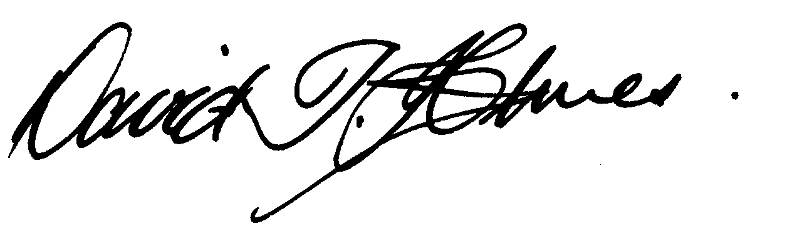
David T Holmes,
Joint Town Clerk

MEETING OF ALFRETON TOWN COUNCIL PLANNING COMMITTEE

ORDER OF BUSINESS
01/20P | To receive apologies for absence
02/20P | To receive any declarations of interest from Members  Members are requested to declare the existence and nature of any disclosable pecuniary interest and/or other interest, not already on their register of interests, in any item on the agenda and withdraw from the meeting at the appropriate time, or to request a dispensation. Please note that appropriate forms should be completed prior to commencement of the meeting.
03/20P | Recording and Filming of Council and Committee Meetings  The right to record, film and to broadcast meetings of the council and committees is established following the Local Government Audit and Accountability Act 2014. This is in addition to the rights of the press and public to attend such meetings. Meetings or parts of the meetings from which the press and public are excluded may not be filmed or recorded. Members of the public are permitted to film or record meetings to which they are permitted access, in a non-disruptive manner.
04/20P | Public Participation  The period of time designated for public participation at a meeting shall not exceed 20 minutes, a member of the public shall not speak for more than 3 minutes, unless directed by the Town Mayor of the meeting.  A question may only be asked if notice has been given by delivering it in writing or e-mail to the Town Clerk before the meeting, unless the Town Mayor regards it as urgent in his opinion.  A separate public participation procedure exists.  https://alfretontowncouncil.co.uk/policies-and-procedures/
05/20P | To consider what representations, if any, the Town Council wishes to make on:  AVA/2020/0156  Address: Land Adjacent 45 Mansfield Road, Mansfield Road, Alfreton, Derbyshire, DE55 7JJ  Proposal: Erection of 30 new build dwelling houses and 4 flats for affordable rent.

Enclosed, for members’ information are the main details of the application. The technical assessments and supporting papers are available for viewing on Amber Valley Borough Councils website:

https://www.ambervalley.gov.uk/planning/development-management/view-a-planning-application/

Enter application reference: AVA/2020/0156

