Alfreton Town Council

Agenda 15th September 2020

#

Room 12,
Alfreton House,
High Street,
Alfreton,
Derbyshire DE55 7HH
Telephone 01773 520032

1st June 2010

Town Mayor and
Elected Members
Alfreton Town Council.
3rd September 2020
Dear Member,

I hereby give you notice that the next meeting of the Full Council will be held virtually by Zoom on:

Tuesday 15th September 2020 at 7:00pm

All Members of the Council are summoned to attend for the purpose of considering and resolving the business to be transacted as set out in the following agenda.

Arrangements for members of the public - if you would like to join this virtual meeting please email office@alfretontc.co.uk. You will then be sent a link and password which will enable you to join.

Yours sincerely,
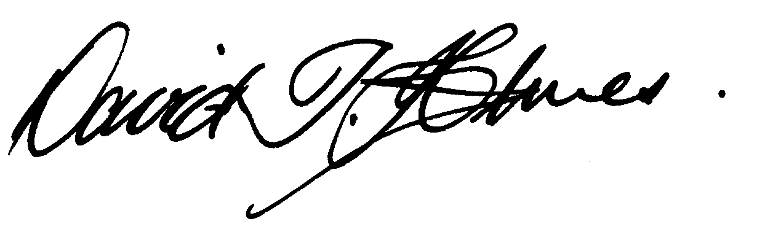
David T Holmes,
Joint Town Clerk

MEETING OF ALFRETON TOWN COUNCIL

ORDER OF BUSINESS
33/20 | To receive apologies for absence
34/20 | To receive any declarations of interest from Members  Members are requested to declare the existence and nature of any disclosable pecuniary interest and/or other interest, not already on their register of interests, in any item on the agenda and withdraw from the meeting at the appropriate time, or to request a dispensation. Please note that appropriate forms should be completed prior to commencement of the meeting.
35/20 | Recording and Filming of Council and Committee Meetings  The right to record, film and to broadcast meetings of the council and committees is established following the Local Government Audit and Accountability Act 2014. This is in addition to the rights of the press and public to attend such meetings. Meetings or parts of the meetings from which the press and public are excluded may not be filmed or recorded. Members of the public are permitted to film or record meetings to which they are permitted access, in a non-disruptive manner.
35/20 | Public Participation  The period of time designated for public participation at a meeting shall not exceed 20 minutes, a member of the public shall not speak for more than 3 minutes, unless directed by the Town Mayor of the meeting.  A question may only be asked if notice has been given by delivering it in writing or e-mail to the Town Clerk 7 clear days before the meeting, unless the Town Mayor regards it as urgent in his opinion.  A separate public participation procedure exists.  https://alfretontowncouncil.co.uk/policies-and-procedures/
36/20 | To consider any items which should be taken in exclusion of the press and public.  If the Council decides to exclude the press and public it will be necessary to pass a resolution in the following terms:- “That in view of the confidential nature of the business about to be transacted, to consider a resolution to exclude the Press and Public from the meeting in accordance with the Public Bodies (Admission to Meetings) Act 1960, s1, in order to discuss the item.  A reason must be stated.  - Item 42/20b To receive a report on Peasehill Allotment due to information relating to an individual  - Item 42/20f To receive a report on tenant occupancy at Alfreton House due to information relating to an individual  - Item 42/20g To consider a request to support a Bachelor of Arts (Honours) Business and Management Project – Nottingham Trent University due to information relating to an individual  - Item 42/20j To receive a verbal report on the foodbank due to commercial confidentiality
37/20 | To hear from a representative of Derbyshire Police should one be available
38/20 | To read and consider the Minutes of the Meeting of Alfreton Town Council held on Tuesday 14th July 2020 copies have been circulated to each Member with the summons to attend the meeting; the Minutes may be taken as read.
39/20 | After consideration to approve the signature of the Meeting Minutes of Tuesday 14th July 2020 by the person presiding as a correct record.
40/20 | To dispose of business, if any, remaining from the last meeting.  There is none
41/20 | To receive and consider reports and minutes of committees.  - Events Committee 23rd July 2020  - Regeneration Working Party 11th August 2020
42/20 | To receive and consider additional agenda items in the order in which they have been notified.
a. | To receive a report on Christmas Event 2020
b. | To receive a report on Peasehill Allotment  (In exclusion)
c. | To receive a report on Environment projects and to ratify costs for maintenance
d. | To receive grant applications from:  - South Normanton Area Foodbank £2500.00
e. | To receive a report on Website Accessibility
f. | To receive a report on tenant occupancy at Alfreton House  (In exclusion)
g. | To consider a request to support a Bachelor of Arts (Honours) Business and Management Project – Nottingham Trent University (In exclusion)
h. | To consider the purchase of 100,000 Dog Bags
i | To receive a report on Local Government Boundary Commission – Electoral Review of Amber Valley Borough Council
j | To receive a verbal report on the foodbank  (In exclusion)
k | To receive the Covid risk assessment for Alfreton House
l | To receive an update on the 20/21 NJC pay award
m | To receive a report on the purchase of a replacement alarm system
n | To review rent of Alfreton House
43/20 | - To authorise the signing of orders for payment.  July £11,126.81  August £13,525.47
44/20 | To receive reports from Members who may have attended Outside Bodies meetings  ACTS MB  Alfreton Community Forum MK  Alfreton Heritage KW  Amber Valley Access CO'B  Pub Watch MB  Derbyshire Unemployed Workers SMC/MK  Alfreton Community Hall SW or nominee  Pentrich Revolution KW  Police Forum SMC
45/20 | To ratify Planning Applications:  AVA/2020/0620  Address:151 Nottingham Road, Alfreton, Derbyshire, DE55 7FL  Proposal:Proposed single storey rear extension to existing dwelling  - No representations made  AVA/2020/0545  Address:100 Mansfield Road, Alfreton, Derbyshire, DE55 7JP  Proposal:Change of use of residential ground floor to Hot Food Takeaway with rear extension and alteration to existing frontage and side elevation and demolition of an out building to create parking to the rear and installation of flue  - No representations made  AVA/2020/0546  Address:100 Mansfield Road, Alfreton, Derbyshire, DE55 7JP  Proposal:Application for advertisement consent for painted wooden pallet style signage to existing and Proposed Hot Food takeaway to create a modern, warming welcome.  - No representations made  AVA/2020/0630  Address:151 Nottingham Road, Alfreton, Derbyshire, DE55 7FL,  Proposal:Proposed single storey rear extension to existing dwelling.  - No representations made  AVA/2020/0633  Address:11 Charles Street, Alfreton, Derbyshire, DE55 7EA,  Proposal:Retrospective proposal for the erection of out building and change of use of domestic outbuilding to commercial use as a personal training studio for private and public use.  - Chair of planning declared interest.  No representations made  TRE/2020/0755  Address:10 King Street, Alfreton, Derbyshire, DE55 7AG  Proposal:Works to Sycamore tree.  - No representations made  AVA/2020/0156  Address:Land Adjacent 45 Mansfield Road, Mansfield Road, Alfreton, Derbyshire, DE55 7JJ  Proposal:Erection of 30 new build dwelling houses and 4 flats for affordable rent.  - A planning committee meeting will be arranged in September  AVA/2020/0755  Address:70 High Street, Alfreton, Derbyshire,  Proposal:Change of use of rear of existing shop to 2 no. 1 bedroom flats with eight new windows.  - No representations made  TRE/2020/0772  Address:The Old Vicarage, 15 Church Street, Alfreton, Derbyshire, DE55 7AH  Proposal:1) Sycamore - Reduce between 25-50%, split stem with first stem leaning towards neighbouring boundary and second stem leaning towards property. 2) Sycamore - Remove down to ground level, split stem sitting within retaining wall area causing damage to wall with growth spreading out to neighbouring listed building.  - No representations made  AVA/2020/0706  Address:85 Mansfield Road, Alfreton, Derbyshire, DE55 7JP  Proposal:Lowering of kerbs  - No representations made  AVA/2020/0806  Address: Loubys Restaurant And Coffee Shop 84 - 86 King Street Alfreton Derbyshire DE55 7DD  Proposal:  Change of use for Ground Floor from Restaurant/Coffee shop to 2no self contained 1 bed flat units  - No representations made
46/20 | To review and approve the following policies:  - Risk Management Plan  - Civic Protocol  - Retention Policy  - Pension Discretions  - Planning Process  - Transparency Policy  - Equality Opportunities
47/20 | To consider 4 topics for communication

