Room 12,
Alfreton House,
High Street,
Alfreton,
Derbyshire DE55 7HH
Telephone 01773 520032

1st June 2010
Alfreton Town Council

#

Town Mayor and
Elected Members
Alfreton Town Council.
16/01/2020
Dear Member,

I hereby give you notice that the next meeting of the Full Council will be held in Room 1, Alfreton House on:

Tuesday 28th January 2020 at 7:00pm

All Members of the Council are summoned to attend for the purpose of considering and resolving the business to be transacted as set out in the following agenda.

Yours sincerely,
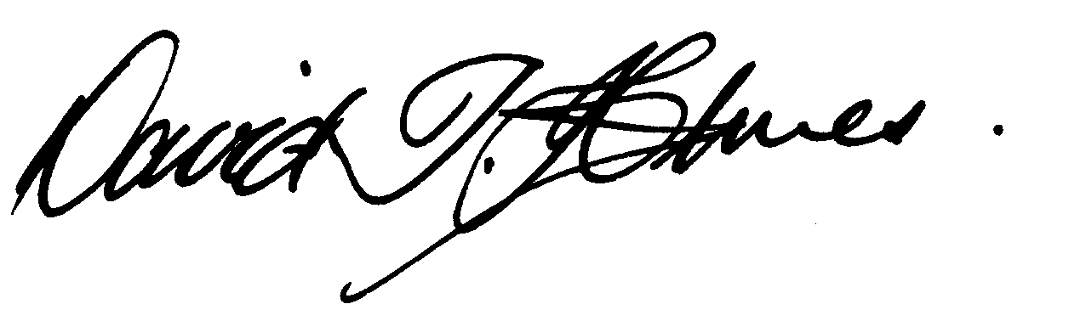
David T Holmes,
Joint Town Clerk

MEETING OF ALFRETON TOWN COUNCIL

ORDER OF BUSINESS
01/20  01/20A |  | To receive apologies for absence.  To hear from representatives of East Midlands Railway regarding EAST MIDLANDS RAILWAY DECEMBER 2020 TIMETABLE CONSULTATION Major changes – have your say  East Midlands Railway published a timetable consultation document in November 2019. That consultation ends on February 14th, 2020 and relates to major changes that the company wants to make in December 2020.  In the consultation document East Midlands Railway, under a heading of ‘General’ on page 30 of the document a question was posed  Will there still be direct services from Alfreton and Langley Mill to London St Pancras International during the week and at weekends?  Answer  We have no plans to continue running direct services to London from those stations. We will however maintain a morning Sheffield to Nottingham service, which will call at these stations and allow connections from Nottingham to London St Pancras International .  Minute 119/19 f of the Alfreton Town Council Meeting 17 December 2019 also refers  The Town Council’s letter to the Secretary of State for Transport is also attached
02/20 |  | To receive any declarations of interest from Members.  Please Note  Members must ensure that they complete all sections of the Declarations of Interest sheet prior to the start of the meeting these will be made available in the Council Chamber.  Column 5 of the Declaration of Interest sheet must be completed in all cases to indicate the action to be taken (i.e. to stay in or leave the meeting prior to any consideration or determination of the item).  The Declarations of Interests will be read out from the Declaration Sheet – Members will be asked to confirm that the record is correct.
03/20 | Public Participation  None received
04/20 | To consider any items which should be taken in exclusion of the press and public.  10/20 b. To consider a quotation for Centenary Green cuts due to its commercially sensitive nature.
05/20 | To hear from a representative of Derbyshire Police should one be available
06/20 | To read and consider the Minutes of the Meeting of Alfreton Town Council held on Tuesday 17th December 2019  copies have been circulated to each Member with the summons to attend the meeting; the Minutes may be taken as read.
07/20 | After consideration to approve the signature of the Meeting Minutes of Tuesday 17th December 2019 by the person presiding as a correct record.
08/20 | To dispose of business, if any, remaining from the last meeting.  There is none
09/20 | To receive and consider reports and minutes of committees.  There are none
10/20 | To receive and consider additional agenda items in the order in which they have been notified.
 | To set a budget and subsequent precept for the financial year 2020/2021
b. | To consider quotation for Centenary Green sectional cuts
c. | To consider receive a report on staff Continued Professional Development – Community Governance
d. | To consider a report on Digital & Climate change action
11/20 | To authorise the signing of orders for payment.  December 2019 £32,925.52
12/20 | To receive reports from Members who may have attended Outside Bodies  ACTS MB  Alfreton Community Forum MK  Alfreton Heritage KW  Amber Valley Access CO'B  Pub Watch MB  Derbyshire Unemployed Workers SMC/MK  Alfreton Community Hall SW or nominee  Pentrich Revolution KW  Police Forum SMC
13/20 | To consider Planning Applications:  AVA/2020/0023 – Access from property to road for a disabled person via a lift (38 The Green, Alfreton, Derbyshire, DE55 7FT)
14/10 | To review and approve the following policies:  - Reserve Policy  - Risk Management and Financial Risk Assessment
15/20 | To consider 4 topics for communication

