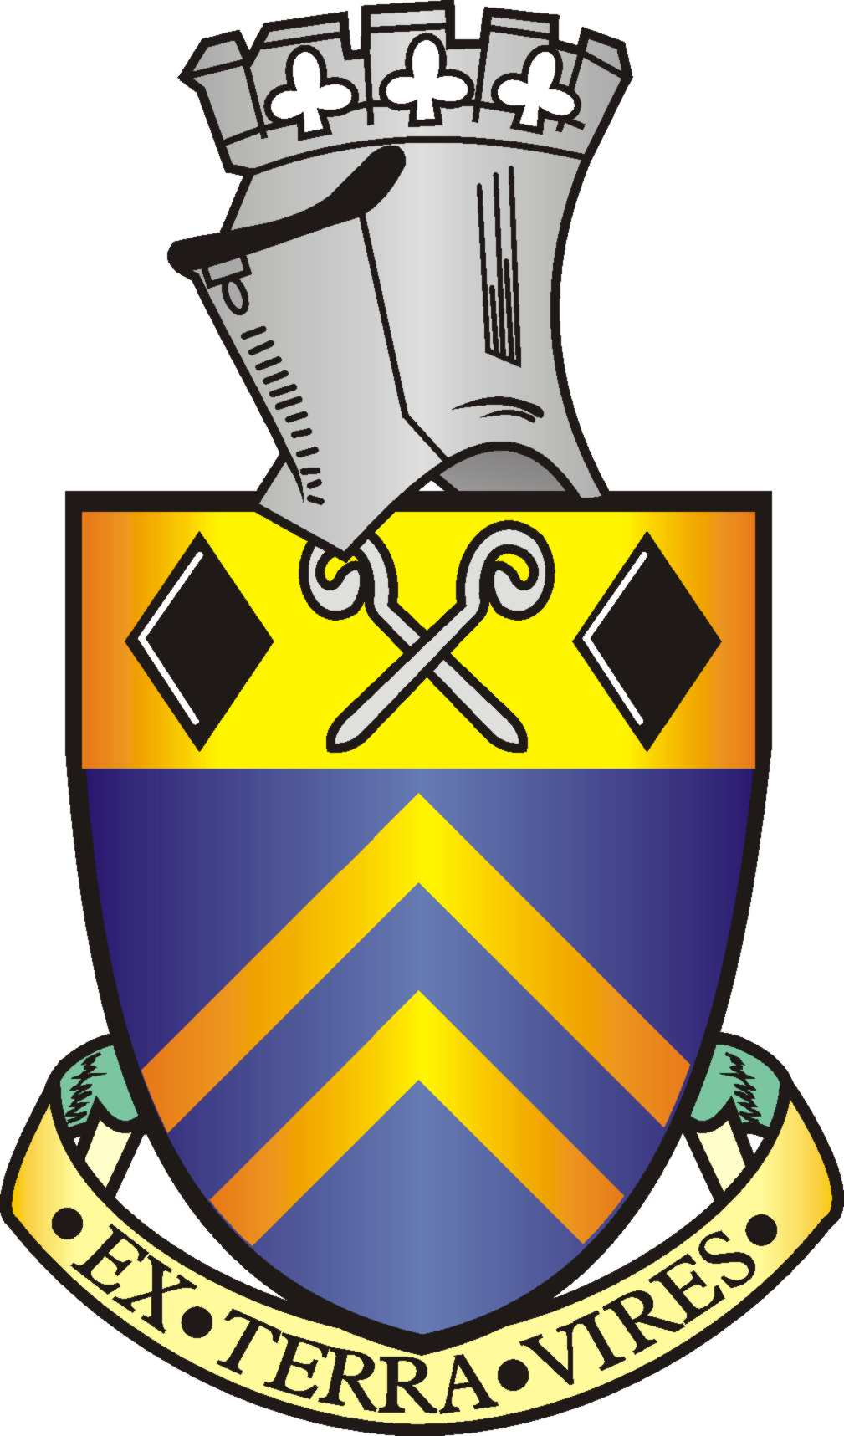

Alfreton Town Council

Health and Safety Policy

Introduction

Management of health and safety is an integral part of Alfreton Town Council and is given the highest priority. Compliance with health and safety legislation is regarded as the minimum standard to be adhered to: our aim is to minimise the number of accidents and work-related illness to the lowest level practicable.

We accept our responsibility for providing a clean and safe environment in which all our Staff, tenants, elected members (councillors) (councillors) and contractors can work. It is our duty to take whatever reasonable measures are necessary for accident and fire prevention and to protect the health, safety and welfare of our employees, elected members (councillors), tenants, contractors and visitors to our premises.

We can only make this policy work with the full co-operation and understanding of all our employees, tenants, elected members (councillors) and contractors. We all need to ensure we carry out our work in a safe manner. All employees, tenants, elected members (councillors) and contractors have responsibilities under the Health and Safety at Work Act 1974 and should report any potential risk (such as faulty equipment or process) to the appropriate manager, and follow all health and safety instructions that may affect them, their colleagues, or the public.

Any Employee found to have deliberately and wilfully breached these regulations in a manner which could reasonably be expected to cause damage or unacceptable risk to the staff, elected members, tenants and contractors could be accused of Gross Misconduct.

Elected Members (Councillors) are expected to follow the instructions within this policy and not to entice staff to breach them. Failure to follow instructions within this policy would bring the office of Councillor into disrepute.

We will endeavour to ensure that all equipment is safe, and will provide personal protective equipment if necessary. So far as is reasonably practicable we will also ensure that our staff and elected members (councillors) are given whatever training is necessary to understand the equipment they work with and to be aware of any potential risks to them.

Information will be provided to employees and elected members (councillors) about particular hazards or dangerous substances related to their jobs. Safety notices throughout the workplace will be clear and prominent.

This policy is non-contractual. All matters affecting health, safety and welfare are kept under constant review. This policy will be reviewed at least annually and also when necessary in the light of experience, changes in legislation, or as need arises or changes.

Organisation and responsibilities

Lead Officer (Tina Crookes).
The Lead Officer is ultimately responsible for ensuring:
• the effectiveness of our overall accident prevention and safety training programme
• that the proper operating practices and procedures to prevent injury are adhered to
and encouraged.
• that all the staff, tenants and elected members (councillors) are aware of their roles and
responsibilities in all health and safety matters.
• that adequate resources are allocated to meet the requirements of this policy as
regards instruction, information, supervision and/or training.

Lead Officer
The Lead Officer is responsible for:
• providing leadership and promoting a responsible attitude towards health and safety
amongst those he/she manages or supervises
• monitoring and auditing our health and safety procedures and working practices to
ensure they are upheld and that we continually strive to make progressive
improvements in health and safety
• promoting awareness of health and safety issues throughout the premises and
ensuring that all staff and tenants are aware of our policy and rules and regular consultation is
undertaken with staff and tenants about issues of health and safety within our workplace
• the maintenance of safety records, investigation of accidents, provision of accident
statistics and keeping a watching brief on safety legislation. Full investigation of
accidents will be carried out by this person with a view to the prevention of future
occurrences. This person is also responsible for ensuring that notifiable occurrences
and accidents are reported under RIDDOR
• conducting, maintaining and updating our risk assessments, reviewing our working
practices and assessing any risks to the health and safety of our employees (or of tenants and
visitors to our premises) arising out of the performance of their duties; ensuring that the
introduction of any new equipment, substance or working practice into the workplace is
properly considered by testing, examination and consultation with staff and
establishing sufficient preventative measures to address any identified risks. Risk
assessments are carried out regularly or whenever there is a significant change to
working practices.
• ensuring our obligations in respect of our COSHH assessment, control and monitoring
of hazardous substances are met
• ensuring that our Fire Risk Assessment is complete and up to date, that fire fighting
equipment is inspected and serviced at least annually and records are kept and
employees trained to use these properly, that fire drills and inspections take place on a
regular basis, that any remedial action is taken to ensure quick and safe evacuation,
and that the appropriate number of fire wardens are "in post" and fully trained
• ensuring that separate risk assessments are done for pregnant workers and any young
people who work for us.
• ensuring that our obligations in respect of assessment, control and monitoring of the
workplace, work equipment, manual handling operations, personal protective
equipment and display screen equipment are met.
• ensuring we have an appropriate number of fully trained first aid personnel and that the
first aid box(es) are checked on a regular basis and restocked where necessary
• ensuring that prompt action is taken regarding any reported damaged or defective
equipment.
• prompting the regular review and monitoring of this policy.
• ensure that each new employee is given induction training which includes the
precautions and procedures appropriate to his/her specific job and that all new
employees and elected members (councillors) are given a copy of our health and safety policy
and any safety rules applicable to their jobs; told of the procedures for reporting accidents,
made familiar with the routine in case of fire or other emergency that might require evacuation
of the premises; shown the location of first aid boxes, fire exits and fire fighting equipment;
and are introduced to the first aid personnel, fire wardens and the Lead Officer.
• ensure that staff reporting to them are only allocated tasks which they are able to carry
out in a safe manner, and for which they have been given the appropriate information,
instruction, and/or training
• ensure that staff reporting to them follow our safety rules and procedures and that a
good level of housekeeping is maintained
• ensure that staff reporting to them are provided with any necessary protective clothing
and that this is worn as instructed
• take appropriate action with regard to all reported defects and complaints relating to
health and safety
• review the health and safety policy periodically and ensure that safety checks have
been carried out in their area of operation
• ensure all accidents that occur in the workplace are recorded, using the appropriate
form and that copies are completed immediately and returned to the Lead Officer.
• ensure that the proper operating practices and procedures to prevent injury are
adhered to and encouraged, and also that they themselves set a good example in safe
behaviour
• ensure any remote workers complete a health and safety checklist and that their
equipment and location receive an annual inspection organised by the Lead Officer.
• keep up to date with health and safety matters applicable to our operation.

All employees’ tenants and workers
All employees, tenants and workers have a responsibility to do everything they can to prevent injury to themselves, their fellow workers and others affected by their actions or omissions at work.

They are required to:
• ensure they are aware of all their responsibilities regarding health and safety
• follow safe working practices and not remove or alter any safety devices on equipment
• ensure that they are fully trained in the use of all equipment that is relevant to their job
• record all accidents or injuries or "near misses" that occur in the workplace, using our
Accident Report form, and seek first aid treatment where appropriate; also report any
accidents or injuries to them which occur either off site or in a tenants office to the
appropriate authority or to the tenant, as well as to our Lead Officer.
• inform the Lead Officer of any serious or imminent danger and
report any shortcomings that they see in the safety arrangements.
• seek guidance from the Lead Officer if they are in any doubt concerning any health and
safety issue
• follow our general safety rules and maintain a good system of housekeeping, including
keeping workspaces tidy
• inform any visitors or contractors with whom they are meeting of any health and safety risks
and precautions they must take.

Authority to stop work
The Lead Member or Lead Officer will have the authority to stop dangerous or illegal practices
and if necessary, to require staff, elected members (councillors), tenants and contractors to stop
work.

Consultation
Effective safety performance will only be achieved by enthusiasm and interest at all levels
within the council’s premises. We will consult with all staff, elected members (councillors) and tenants via written letter by informing them of any changes to working practices, amendments to our safety procedures or changes in legislation. In addition, all workers are encouraged to raise any issues regarding health and safety with the Lead Officer or Lead Member.

Safety information
There are two Health and Safety at Work posters on display. These are on display one on the back of the door in the Town Council Office and one in the foyer.

All employees are provided with a copy of our health and safety policy and rules on joining
our staff. A Policy is to be hung in Room 1, elected members (councillors) room and the foyer.

All accidents should be recorded in the Accident Book which is kept in the Town Council Office .

Copies of our risk assessments and COSHH assessment (by cleaner) are kept by the lead officer and will be supplied to staff as appropriate to their jobs.

The fire regulations and evacuation procedures are displayed in the foyer. All staff, tenants and contractors are instructed to read these carefully, and to know what to do in the event of a fire.

The Town Council have 4 first aid boxes which are kept in the Town Council Office , in the Town Council Vehicle, the kitchen and in Room1. Workers are requested to inform the First Aider if any replacement items are needed. The name of our first aider is on the first aid box. Our first aider is fully trained and should be contacted in the event that an employee requires first aid treatment. Also a Photograph of our First Aider should be displayed in a prominent position and who to contact when the staff member is not on the premises.

Hazard reporting

All workers must report any potential hazard or unsafe working practice to the lead officer. If the hazard or unsafe working practice presents an immediate danger, it should be reported to the most senior person present at the time. This person has the authority to take immediate action to alleviate the danger, including the stopping of any work until further action is taken. Any damaged or defective equipment should be reported to the lead officer immediately.

Health and safety rules
A copy of our general health and safety rules is given to each new employee on joining us
and is also displayed in the Town Council Office, Room 1 and elected members (councillors) room all staff and elected members (councillors) should ensure that they are aware of these and follow them.

Smoking
Our premises (Town Council Building known as Alfreton House) are designated "no-smoking" areas and this must be observed at all times by all employees, tenants, elected members (councillors), contractors and visitors. Failure on the part of employees to comply with this request may lead to disciplinary action.

Alcohol and illegal drugs
Alcohol and illegal drugs are not allowed onto our premise. Any employee who is found with these substances or whose ability to work is impaired due to them may be suspended and subject to disciplinary action. We currently do not undertake any routine or random testing for drugs or alcohol. The Exception to this is holding alcohol on site for prizes or gifts. Also for entertainment purposes at Council social events.

Pregnant women and those of child bearing age
A separate risk assessment covering pregnant women and those of child bearing age is
regularly reviewed by the Lead officer or Lead Member. Once we are informed that an employee is pregnant or is breast-feeding, a specific risk assessment will be undertaken for that individual.
All necessary steps will be taken to reduce any risk to the employee or her child.

Young workers
A specific risk assessment will be carried out before employing a young person (any person
who has not attained the age of 18). In particular, we will consider the inexperience, lack of
awareness or risks and immaturity of young persons; the fitting-out and layout of the
workplace and workstations; the nature, degree and duration of exposure to physical,
biological and chemical agents; the form, range and use of work equipment and the way it is
used; the organisation of processes and activities; the required training as regards health and
safety and other specified risks. This should also be brought to the attention of our tenants.

In addition, we will provide the parent with comprehensible and relevant information on the
risk to health and safety identified by the assessment and the preventative and protective
measures taken.

Manual handling
All reasonable effort is made to limit the need for manual handling within the Council Premises.
However, where necessary, employees will be provided with information and training on safe
handling.

VDU users
Regular risk assessments are carried out for those employees who use VDUs on a regular
basis and reasonable measures taken to reduce the risk of repetitive strain injury. In addition,
training will be provided on the safe use of the equipment, and an assessment of each
workstation undertaken. We will meet the cost of regular eyesight tests and also the provision
of spectacles specific for VDU use where these are deemed necessary.

Security
All reasonable efforts are made to provide secure premises and to ensure that staff can enter
and leave our premises safely. Access to any potentially hazardous areas is limited to
authorised persons. When leaving work at the end of a shift, employees are responsible for
locking away confidential documents or valuable items. Anyone working on site or alone on
our premises should be made aware of our lone workers policy and ensure that they comply
with the safety rules relating to them.

Medical checks and health surveillance
If any medical tests are necessary prior to an employee joining, this will be made clear on the
offer letter and in the contract. It is a term in all of our employment contracts that employees
should undergo a medical examination at any time should we have concerns about their
health and feel this to be necessary.

Implementation, monitoring and review of this policy
This policy will take effect from the date of adoption. The Lead Office has overall
responsibility for implementing and monitoring this policy, which will be reviewed on a regular
basis by the Health & Safety Committee or lead officer and lead member following its implementation (at least annually) and additionally whenever there are relevant changes in legislation or to our working practices.

Any queries or comments about this policy should be addressed to the Lead Officer.

Received Copy of Alfreton Town Council Health & Safety Policy

Signature............................................................................................................................

Date.......................................................................................................................................................

Capacity in which received:

Employee

Elected Member (councillor)

Tenant

For office use only
Date and place in either staff file or Member and Tenant file..............................................................

