18th October 2012

Alfreton Town Council

Mr Derek Stafford
Asst Director Planning and Regeneration
Borough Development Department
Development Services
Town Hall
Ripley
Derbyshire
DE5 3SZ

Dear Derek,
Alfreton Town Council’s Representation to the Alterations to Planning Application AVA/2012/0084 Residential Development for up to 500 Dwellings and Associated Works at Land at Outseats Farm, Alfreton

The Town Council, as you know, has already submitted its major concerns about this application; those concerns still prevail and continue to form the Town Council’s representations to this application.

With regard to the recent alterations to the planning application:-
The Town Council has to accept the archaeological survey as presented. However, given the limited ‘trial excavations’ and the site’s history as hinterland to Carnfield Hall, it is expected that the Planning Authority would apply a condition to any approval which requires any works to be closely monitored, at every stage, to ensure that any new archaeological evidence which may be revealed is reported and that works are halted to allow reassessment.

The Town Council remains deeply concerned about the traffic impact of this application and the additional information does nothing to allay that concern. An original proposal to use access from land adjacent to Leys School was one that alarmed the Town Council, whilst its apparent removal from the application is sensible, in the Town Council’s view should not have been there in the first place. Without a satisfactory alternative, it only exacerbates the Town Council’s concerns about the effect on traffic in the Birchwood Road area.
The Town Council also seeks better information on the proposals for the ‘Bus Gate’. Its inclusion in the application only confirms the Town Council’s strongly held view that traffic flows through the proposed development are a major issue.
The Town Council feels that the application still fails to convince on the major issue of traffic congestion and safety, the Town Council has already alerted the Planning Authority to the following requirement

The Town Council asks that Amber Valley Borough Council does not simply rely on the applicant’s Transport Assessment and demands that Derbyshire County Council undertakes and publishes their own in depth Transport Impact Assessment, not only on the proposed roundabout but also the effect on estate roads, school children safety and importantly the effect on traffic congestion in the Town itself. The reason for this is that people locally have serious difficulties in relating the conclusions drawn in the report from the data presented in the report. Crucially, local people fear the proposal would create accident black spots and significant unacceptable traffic congestion, which do not appear to be acknowledged in the Traffic Assessment.

The Town Council is concerned that this application, as yet undetermined and with significant local concern, continues to feature in the Borough Council’s Preferred Growth Strategy.
Comments from local people show that they fear that the site’s inclusion in the Preferred Growth Strategy means that the planning application is in effect a ‘fait accompli’ and clears the way for approval of the application. Alfreton Town Council feels that its inclusion sends a confusing message to local people on a process which should be based on certainty and sustainability. Consequently, the Town Council calls upon the Planning Authority, to remove this application, at this stage, from the Preferred Growth Strategy
Yours sincerely,
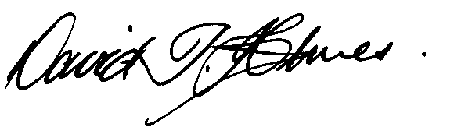
David T Holmes
Town Clerk
c.c. Rae Gee, Principal Planning Officer

Room 12 Alfreton House High Street Alfreton Derbyshire DE55 7HH

Q
QUALITY
TOWN
COUNCIL
Telephone 01773 520032 Office Hours: Tuesday to Thursday 9-00 am to 12-30pm.
E Mail alfretontc@aol.com

Town Clerk: David T Holmes MBA Chartered FCIPD CiLCA
Assistant Town Clerk and Treasurer: Mrs Sheila Gent CiLCA

